

Software Design Document for project

MSA Graduation Projects Management System

Abdelrahman ezz –eldin

Mena Hany

Mostafa Mohamed Saeed

Abdelaziz Ashraf

Rana Reda

Supervised by: Dr.Ayman Ezzat

December 30, 2020

1 Introduction

1.1 Purpose

This software design document describes the architecture and system design of MSA Computer Science Graduations Management System, its intended audience are the professors, students and the staff of the faculty of computer science at MSA and external computer science committees intended to collaborate with MSA University in the faculty of computer science.

1.2 Scope

This software is intended to manage the process of the students’ graduation at the faculty of computer science at MSA University. This system should ease the process for the professors and computer science staff to manage and monitor the students’ during the graduation phases through monitoring their file uploads and grades throughout their graduation project phases while allowing the students to work in a more managed and systematic environment.

1.3 Overview

Activity Diagram.

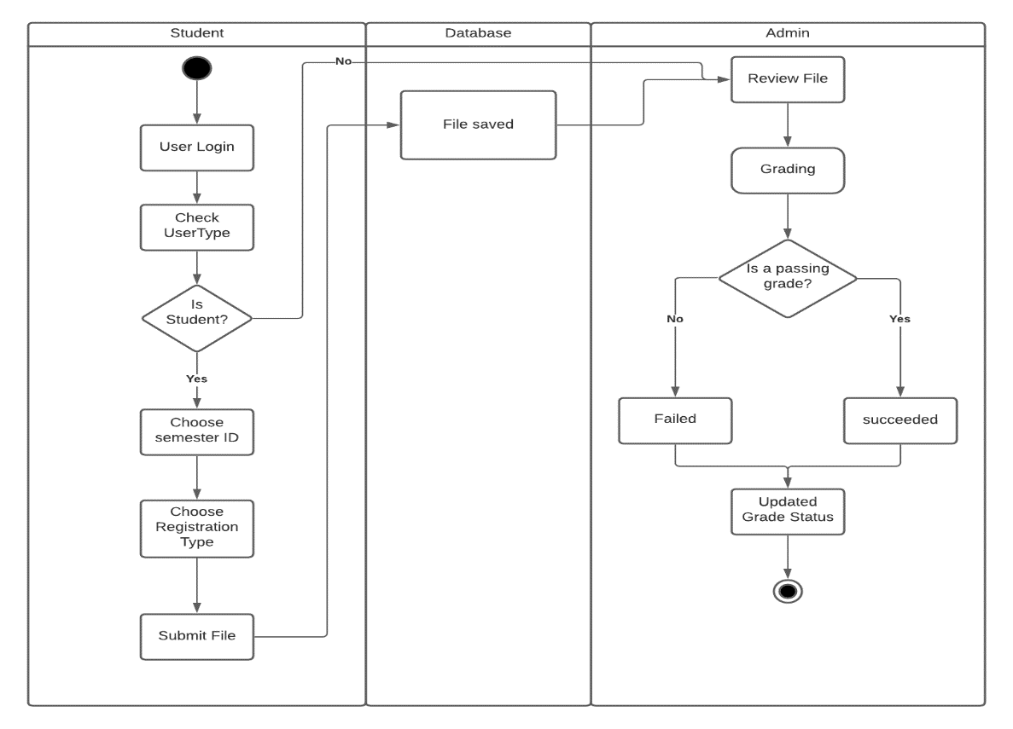

/ Doctor

2-Sequence Diagram

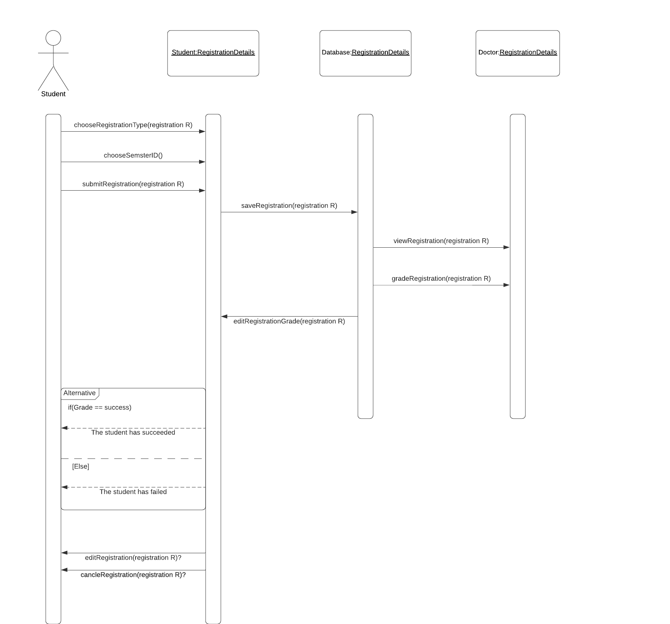

3 System Architecture

3.1 Architectural Design

Figure 1: Block Diagram

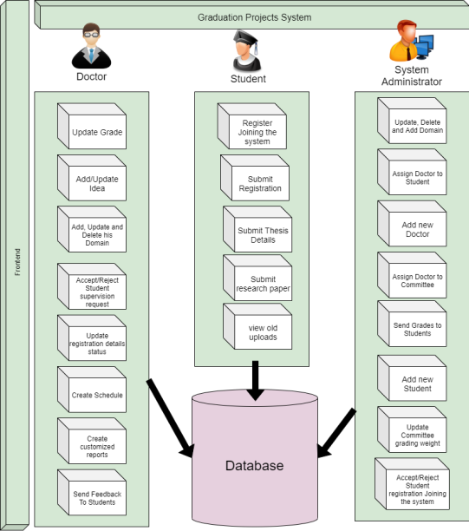

Figure 2: Hardware Diagram

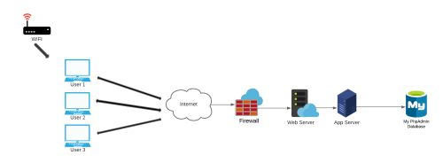

Figure 3: Process Diagram



Figure 4: Logical Diagram

Student Logical Diagram

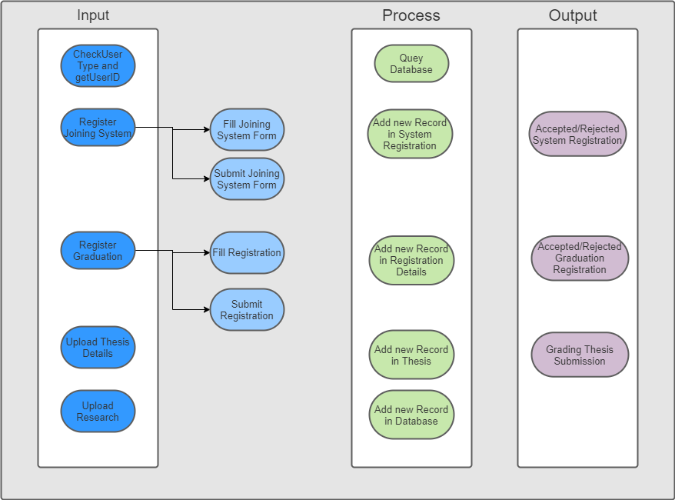

Doctor Logical Diagram

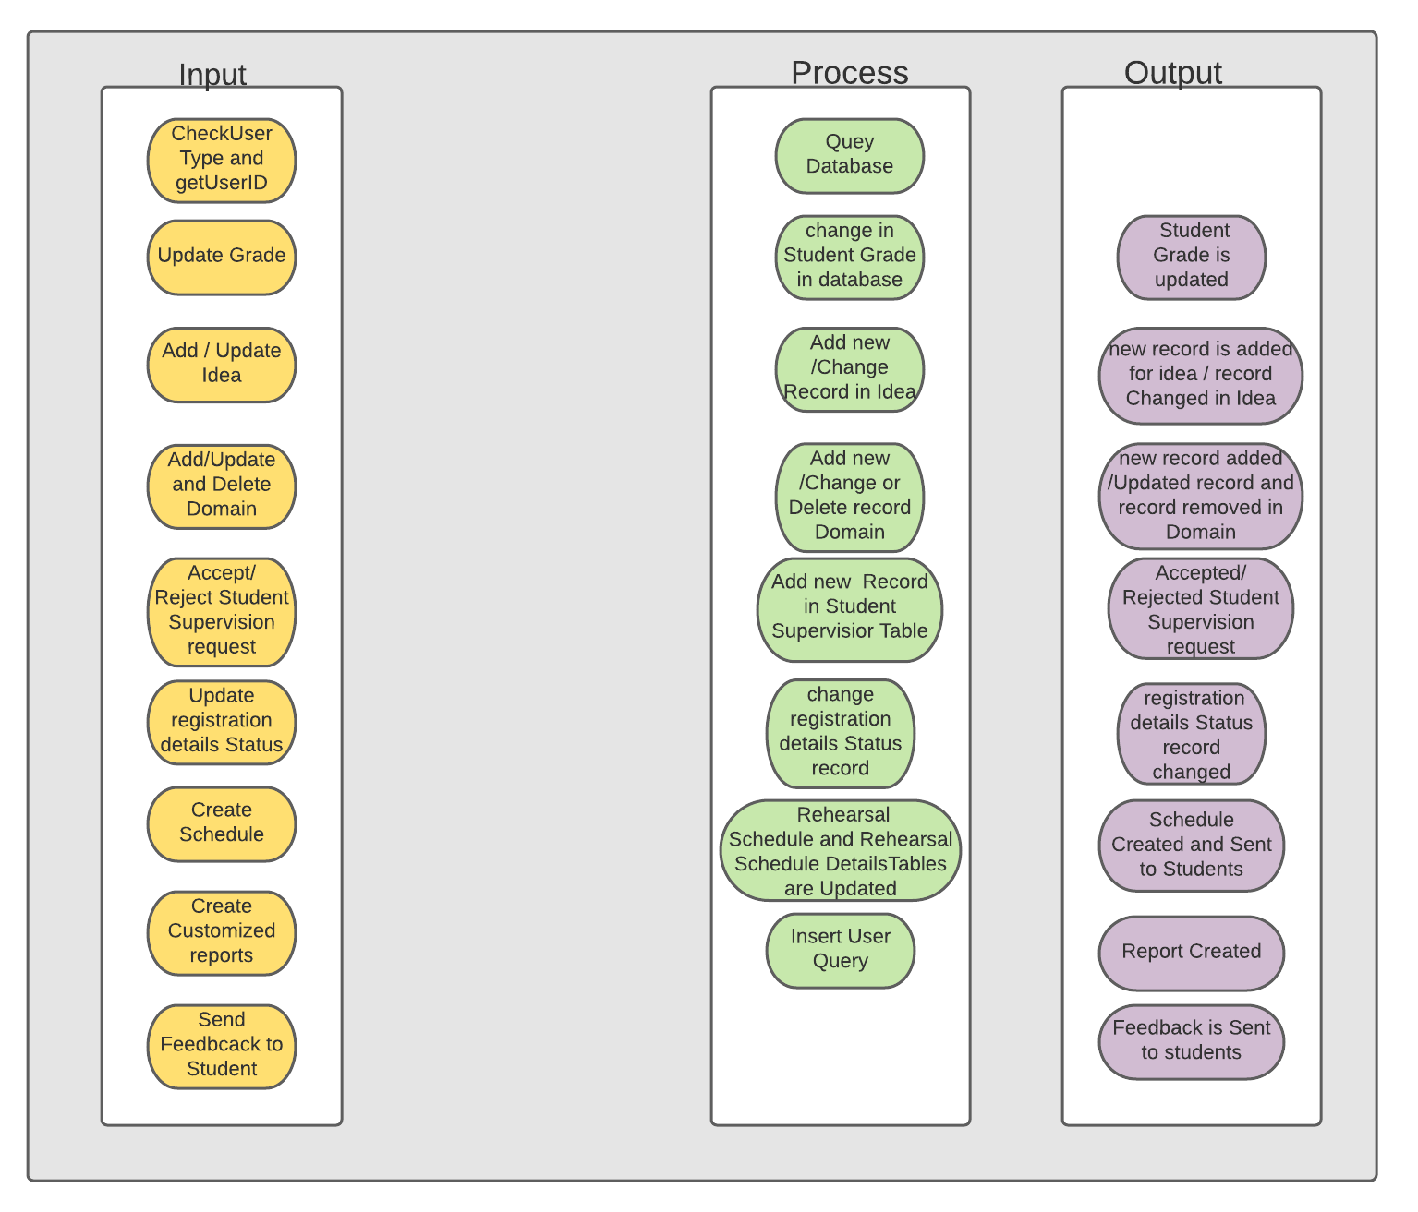

Admin Logical Diagram

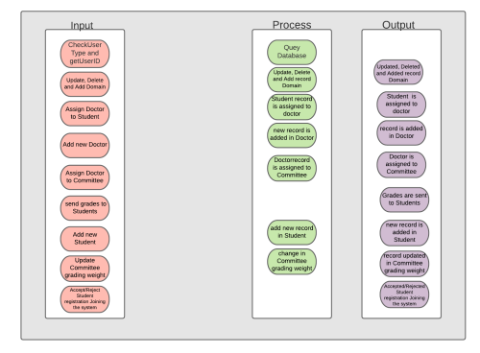

3.2 Decomposition Description



4 Data Design

4.1 Data Description

1. Strategy Design Pattern we used the strategy for encryption in encrypting the file name uploaded by the student.
2. Single Tone Design Pattern we used the single tone design pattern in our connection to the database and our php mailer construction Factory Design Pattern we used the factory design pattern for constructing the Admin, Doctor or Student objects.
3. Decorative Design Pattern we used the decorative design pattern to calculate the student phase grade that is given by multiple committees.
4. Observer Design Pattern we used the observer design pattern to send emails and smsses to students and drawing a bar chart of the average grade of the students.
5. Facsade Design Pattern we used the Fascade Design Pattern to connect to our php mailer.

4.2 Data Dictionary



6 Human Interface Design

6.1 Overview of User Interface

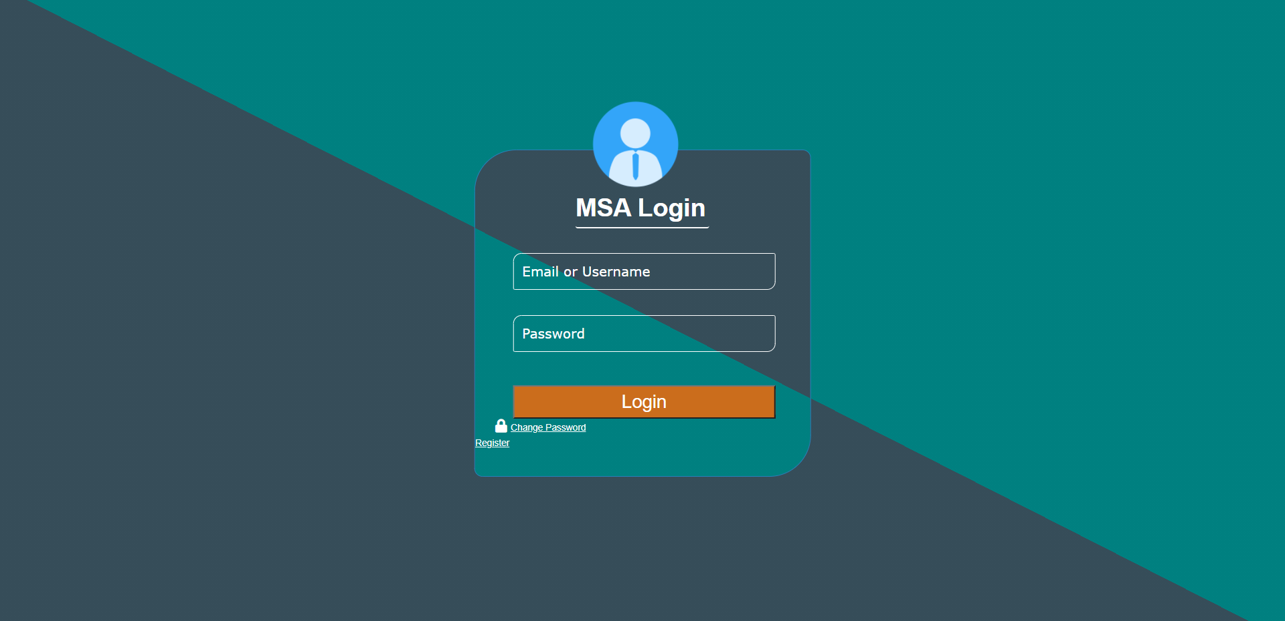

Registration Form:-

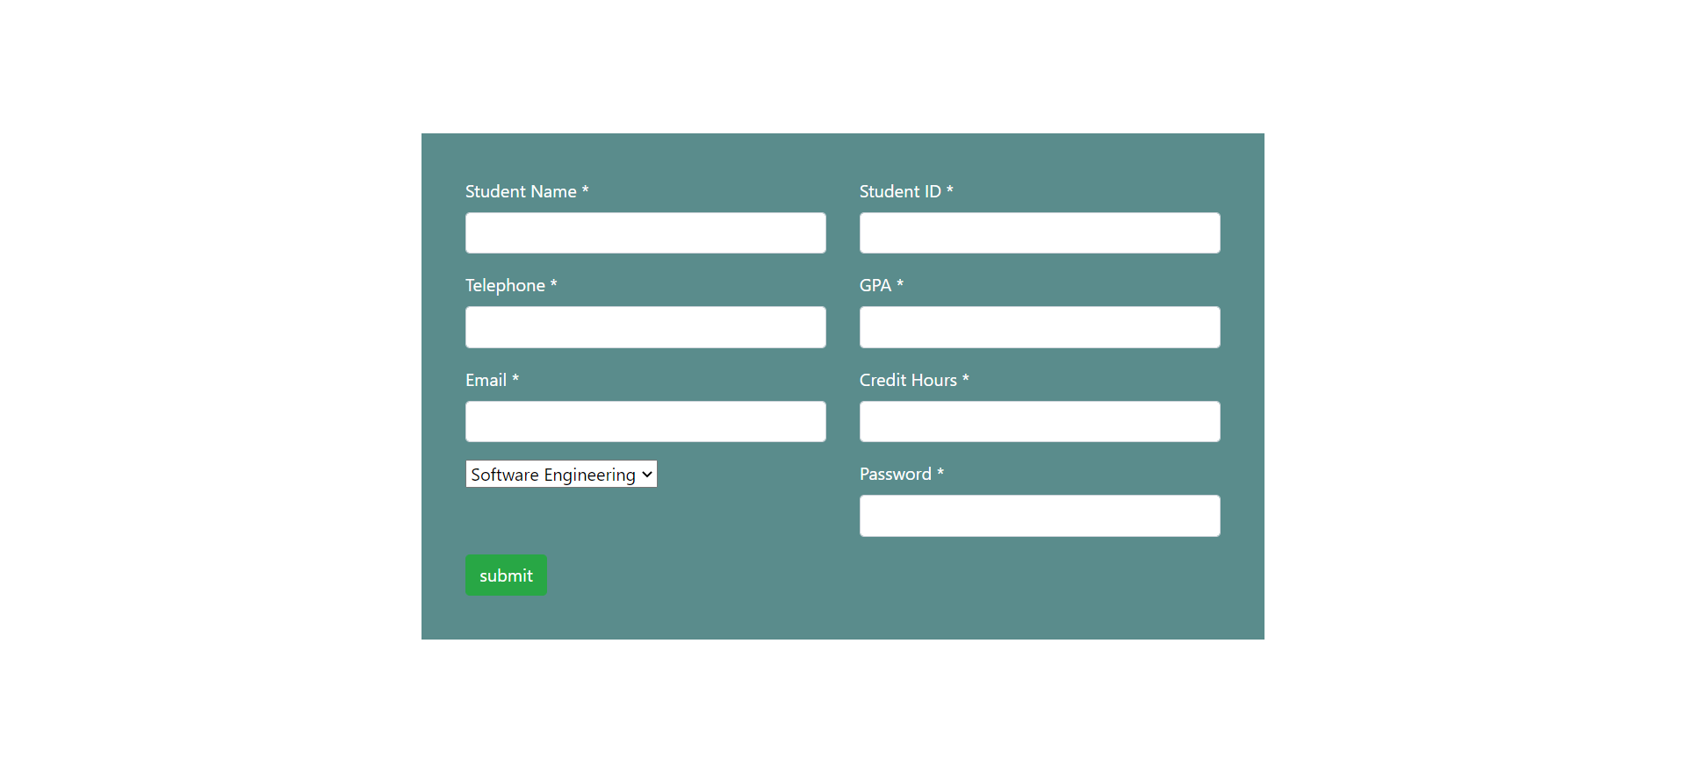

Forget Password Page:-



6.2 Screen Images

Students Pages:-

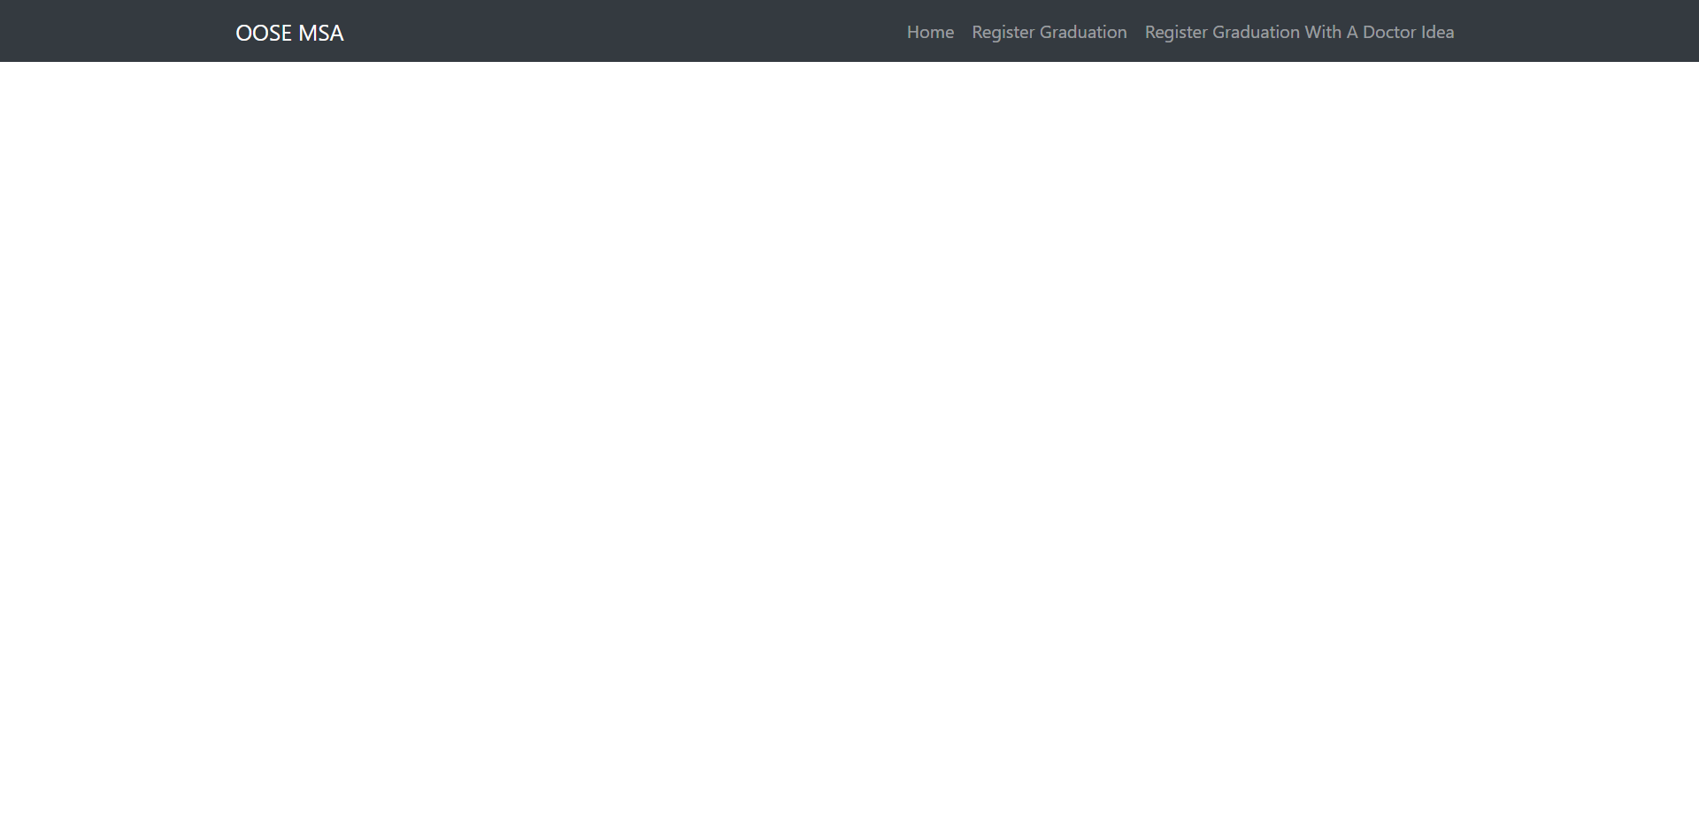

Doctor Landing Page:-

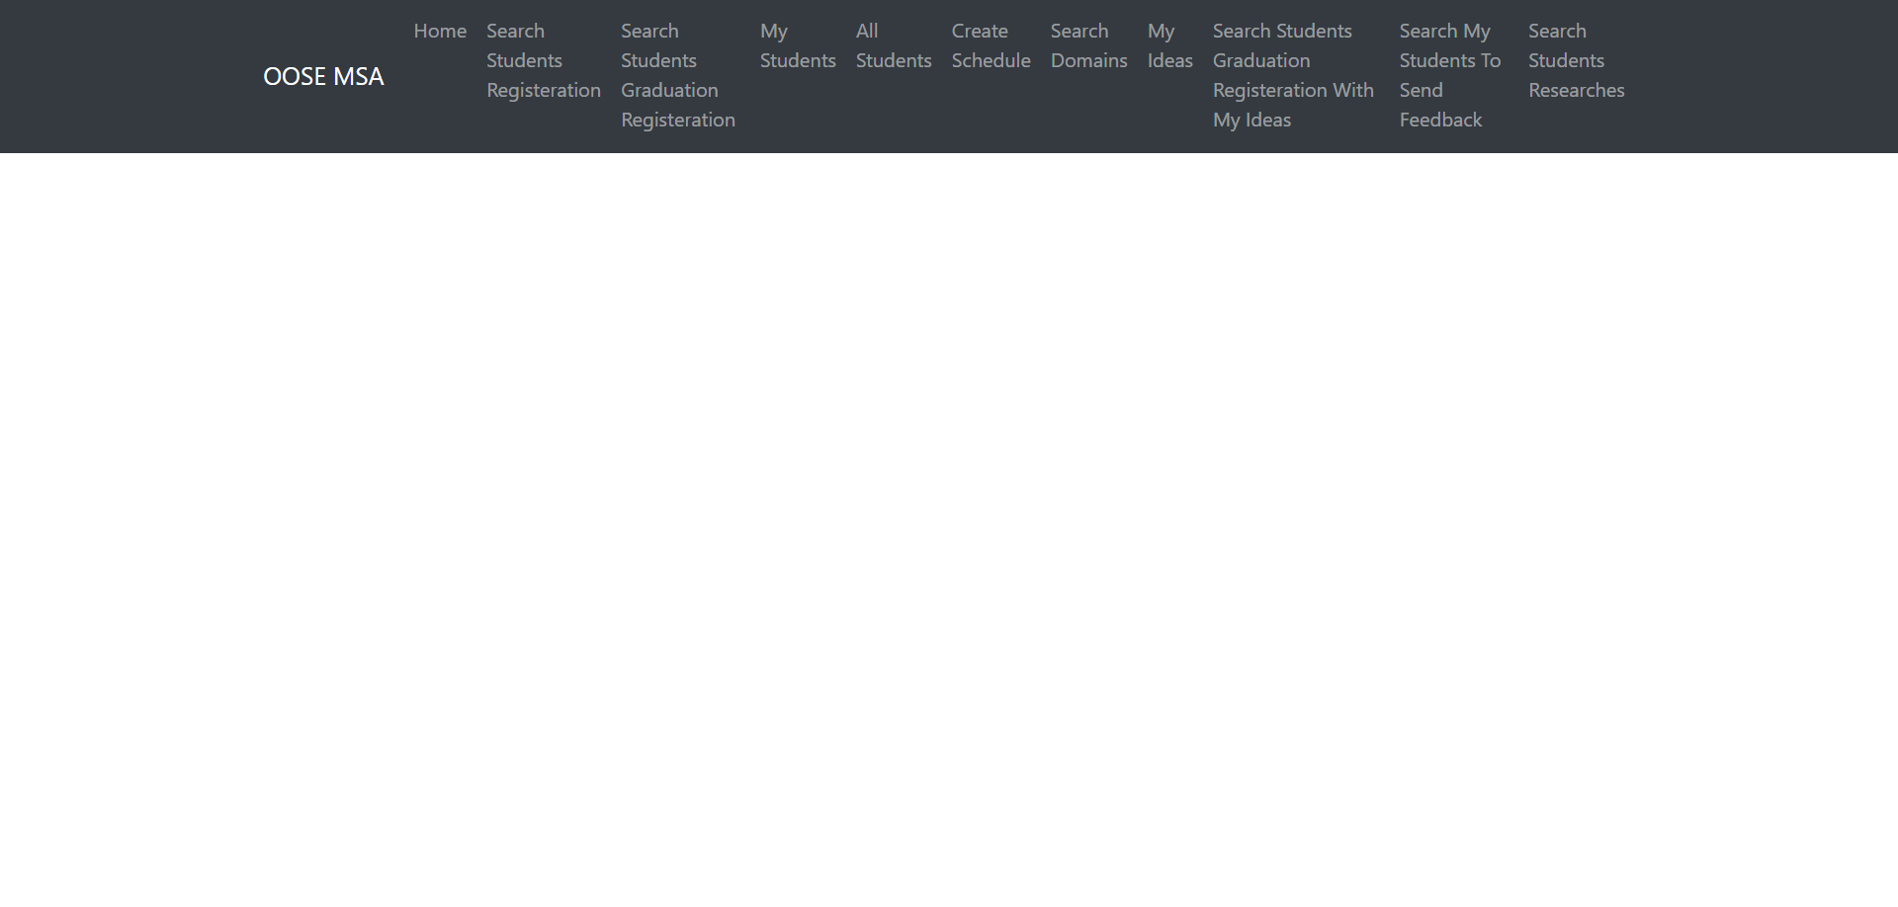

Admin Landing Page:-

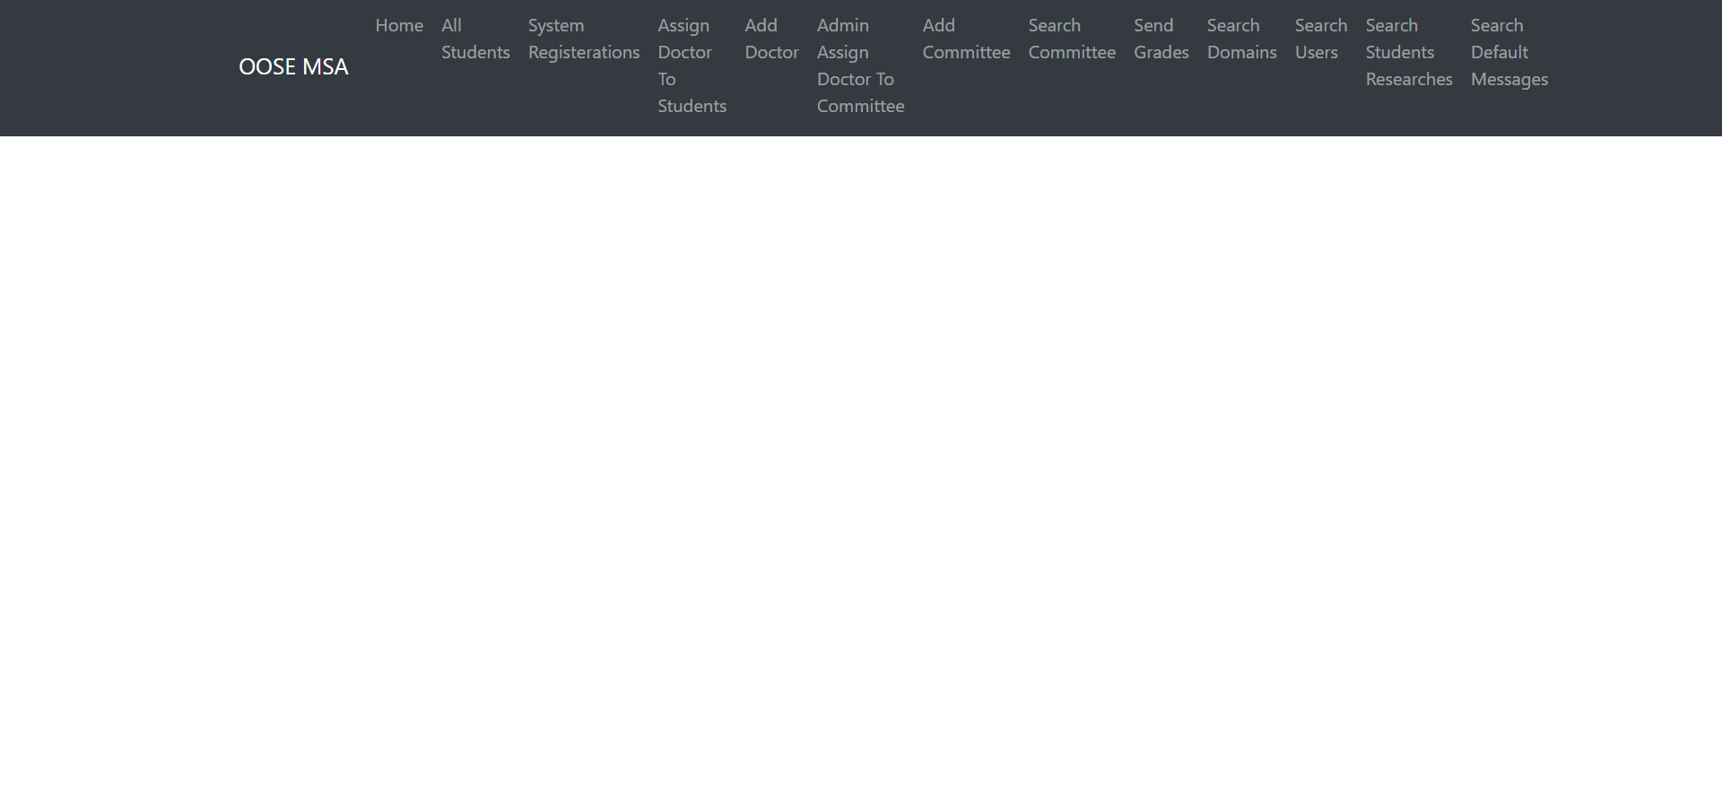

6.3 Screen Objects and Actions

A discussion of screen objects and actions associated with those objects.

Page2:-

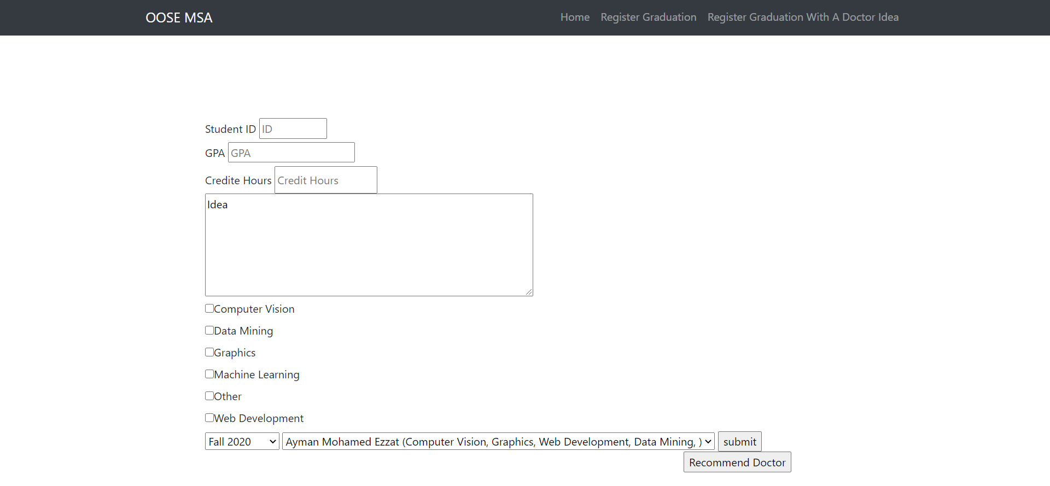

Page3:-

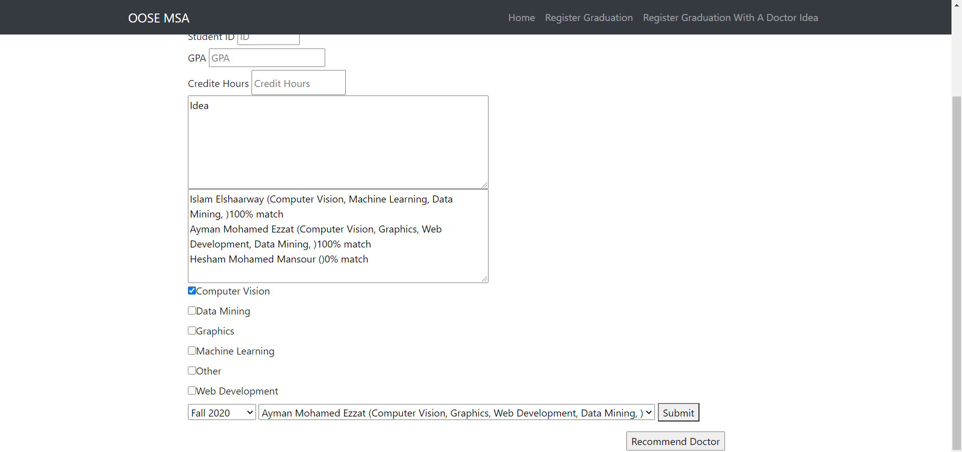

Page4:-

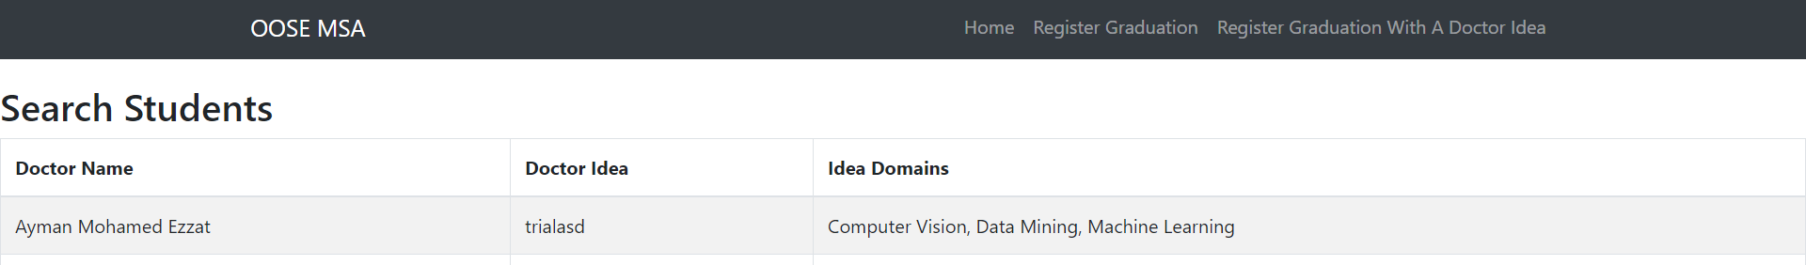

Page5:-

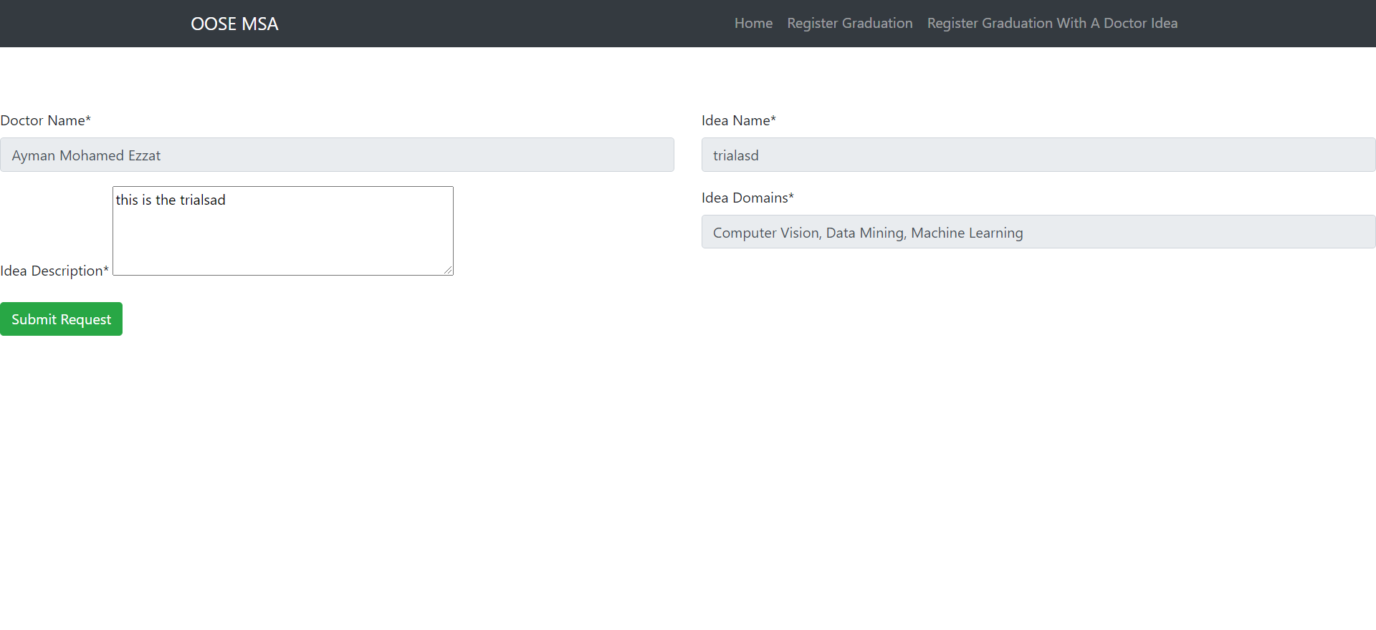

Page6:-

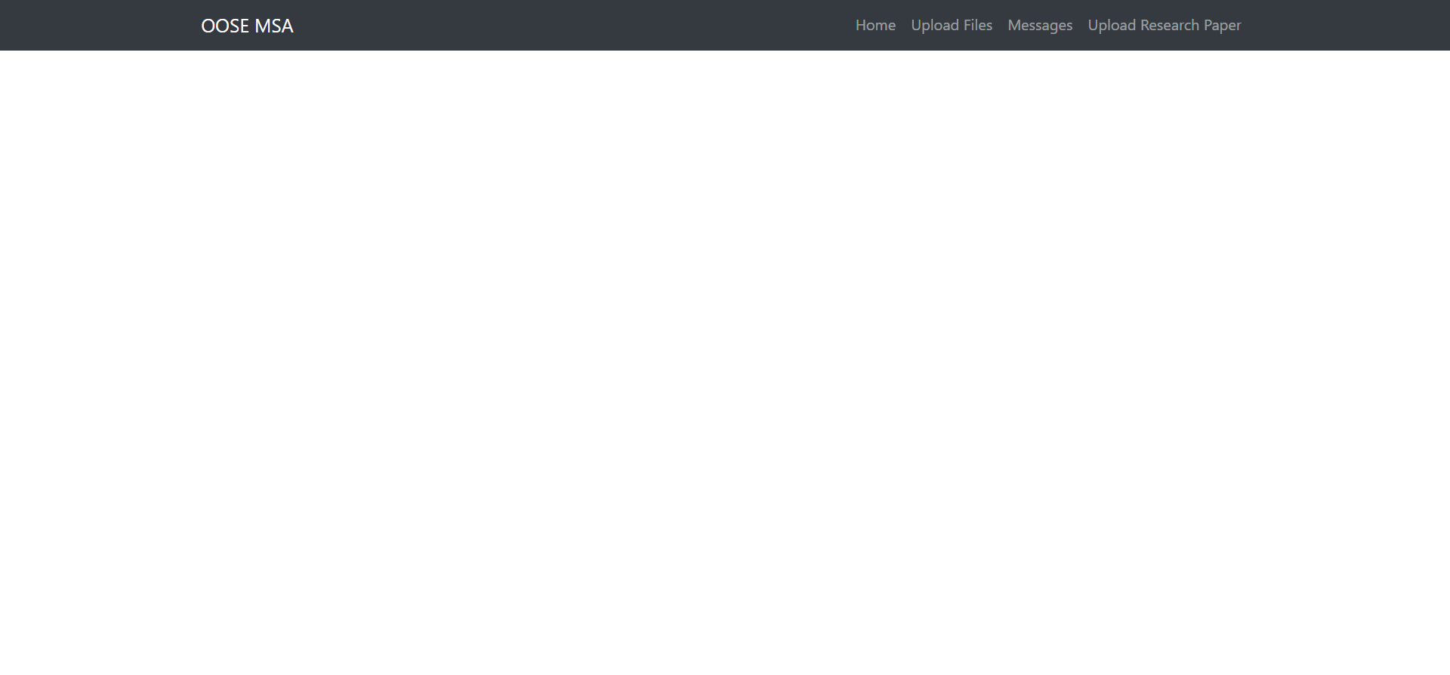

Page7:-

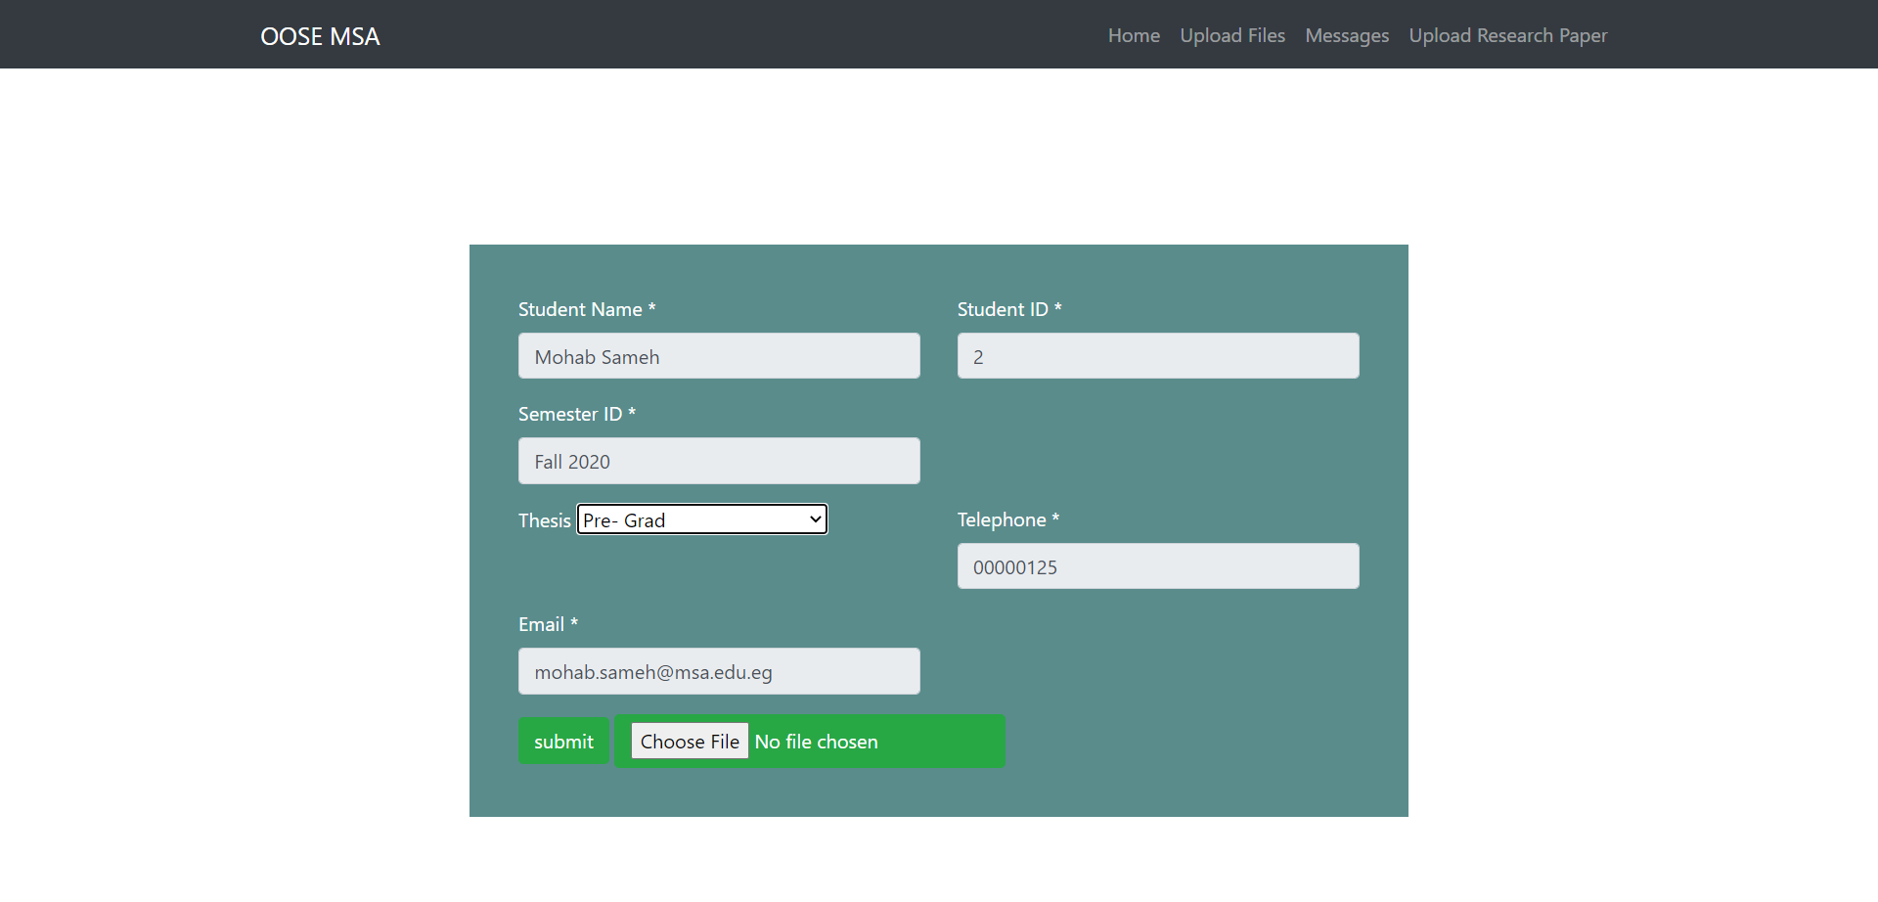

Page8:-

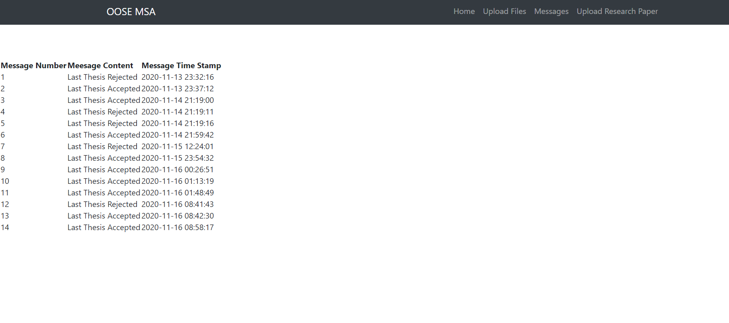

Page9:-

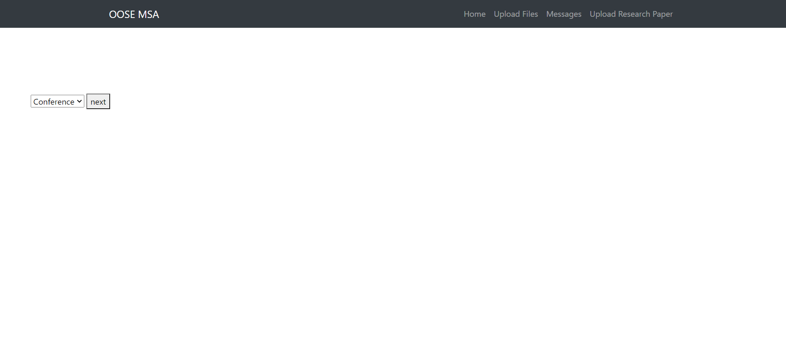

Page10:-

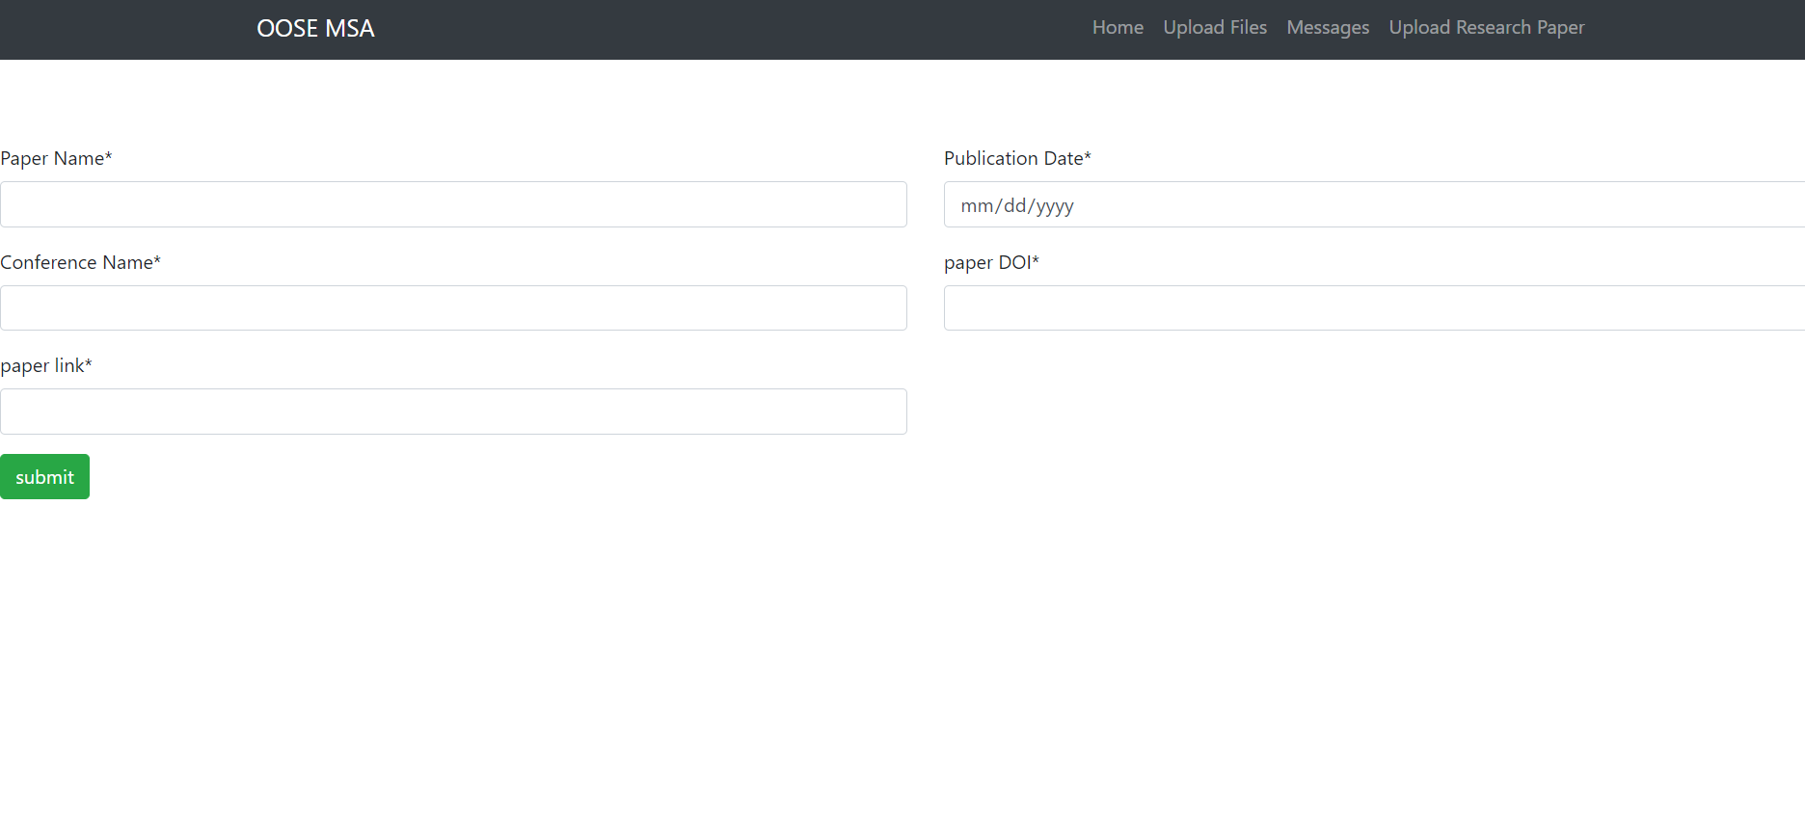

Page11:-

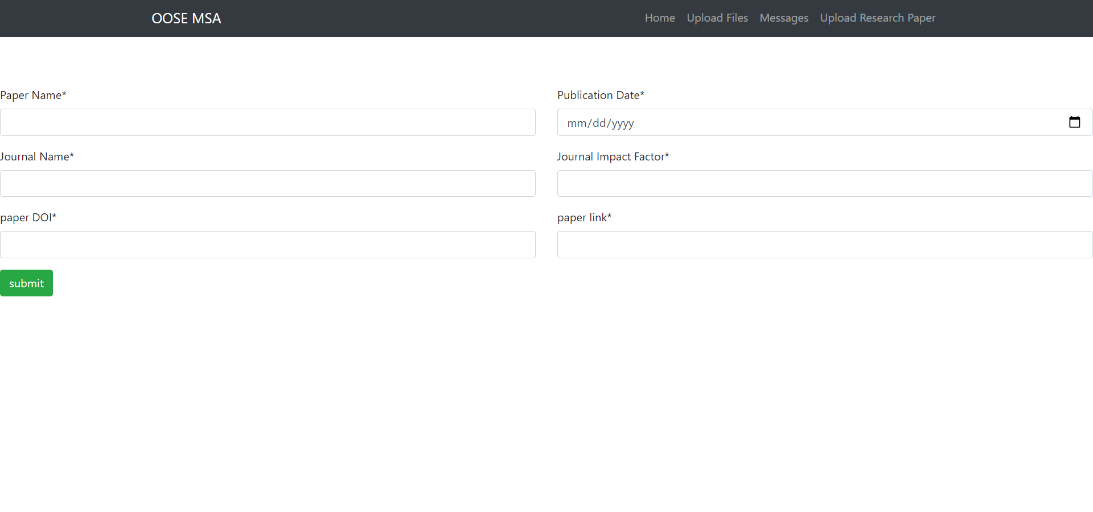

Doctor pages:-

Page2:-

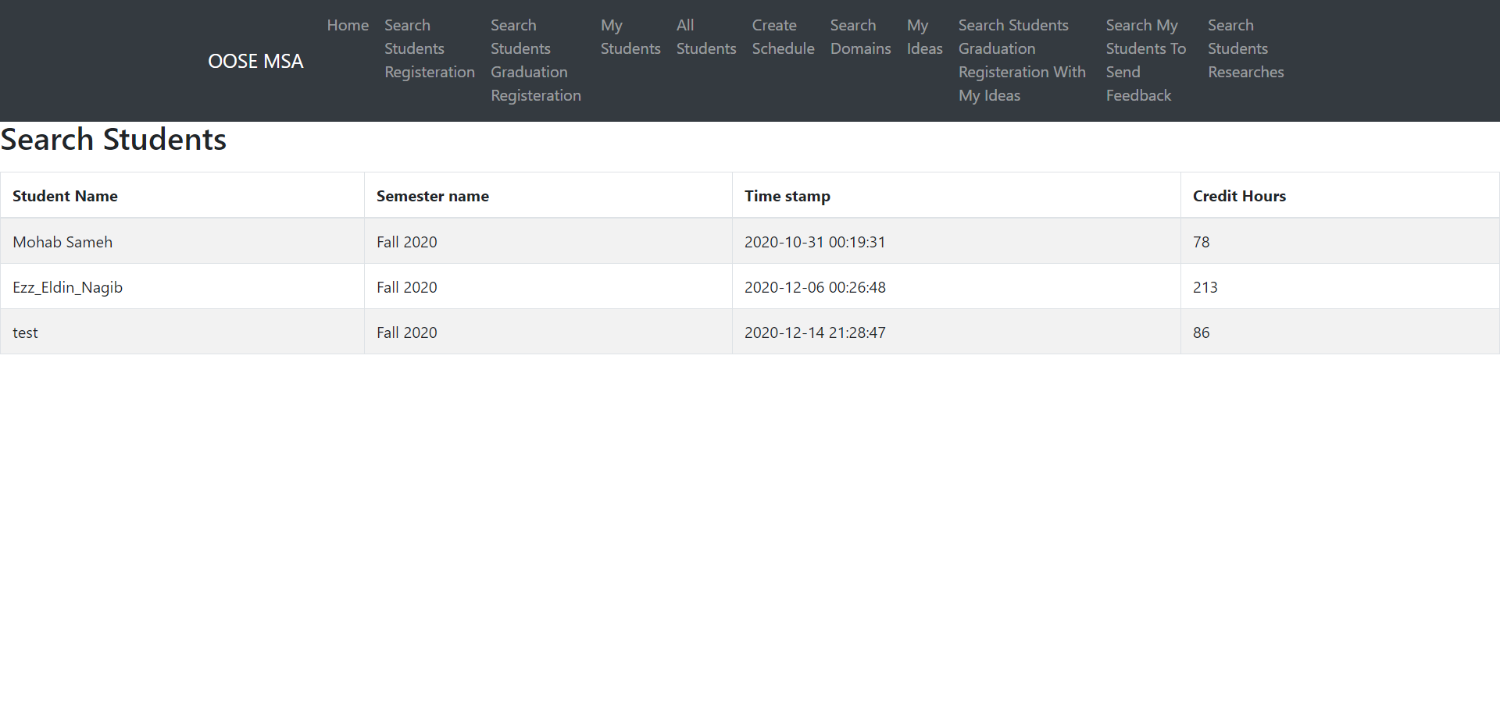

Page3:-

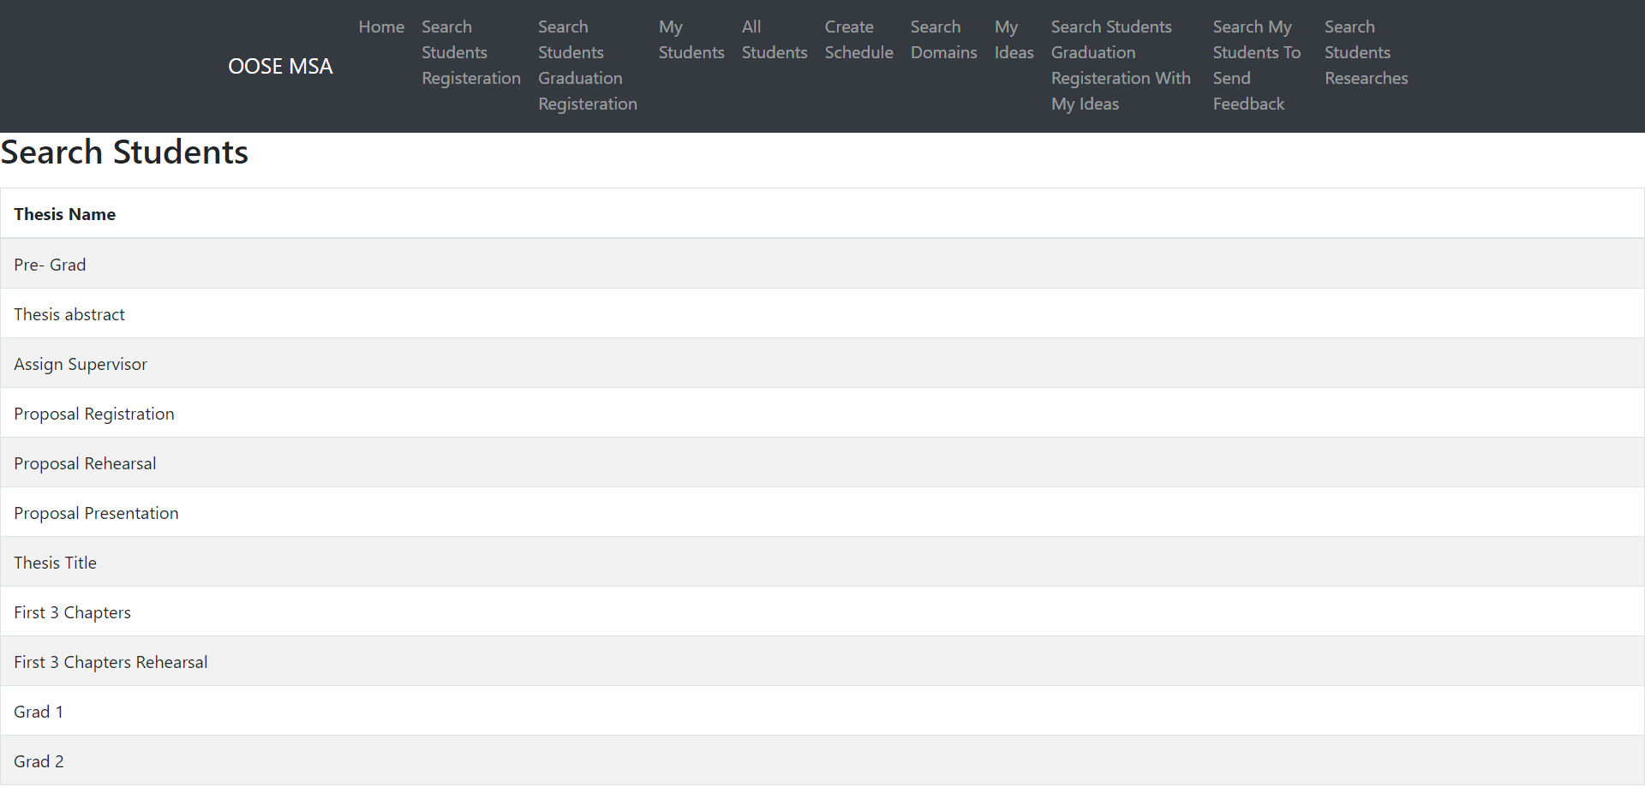

Page4:-

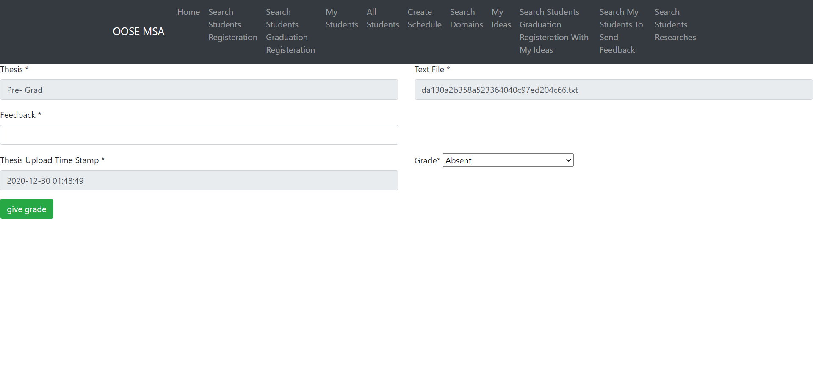

Page5:-

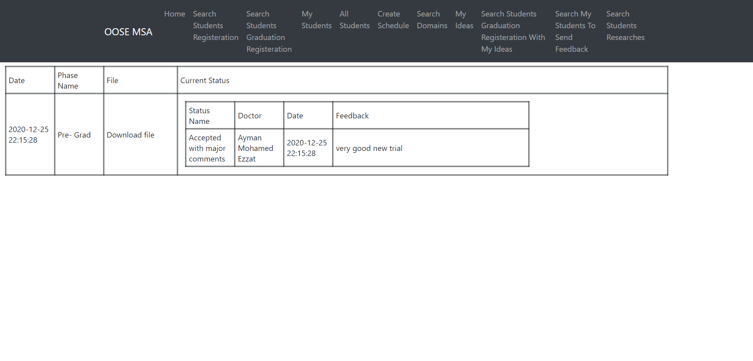

Page6:-

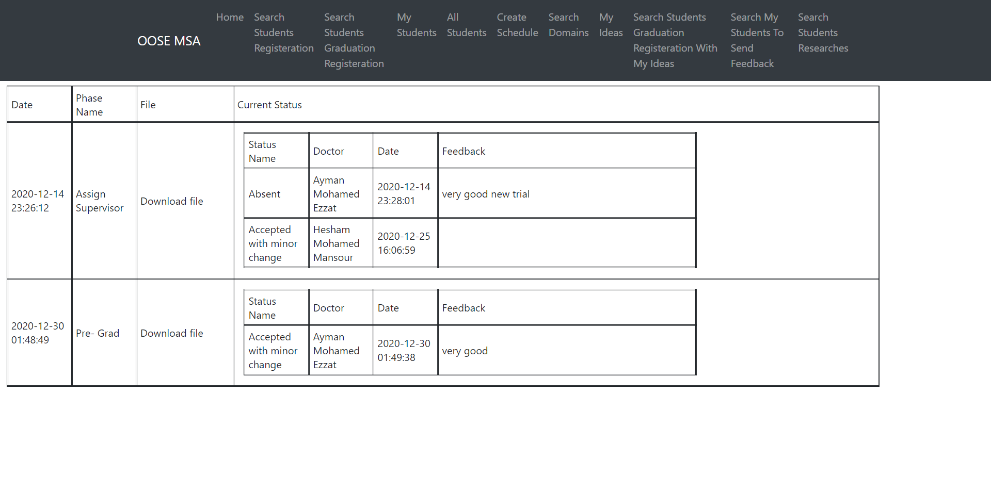

Page7:-

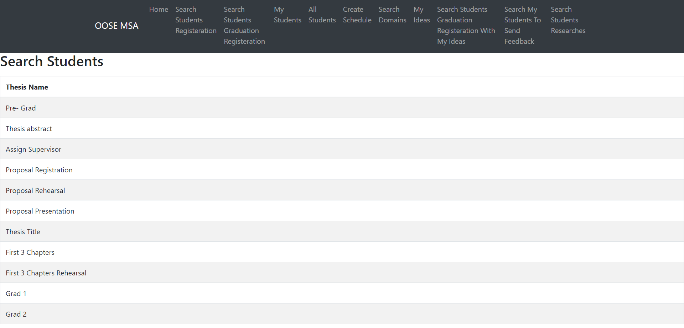

Page8:-

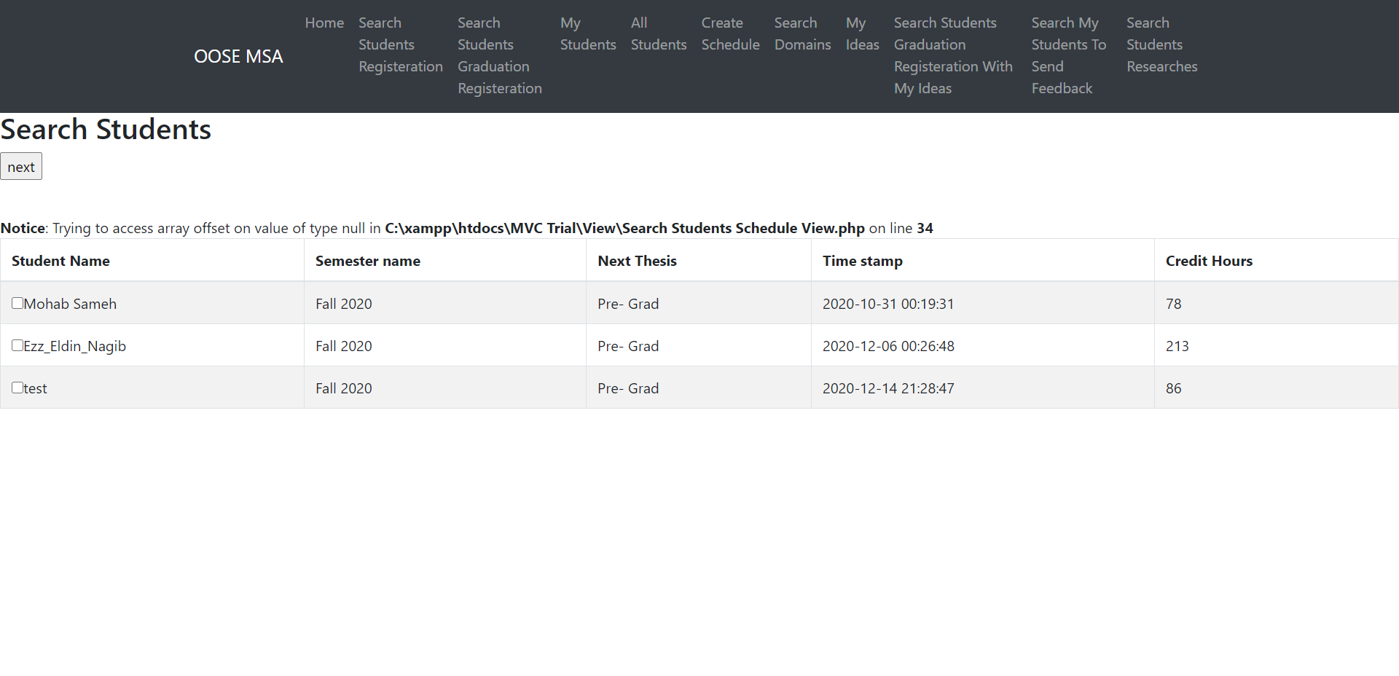

Page9:-

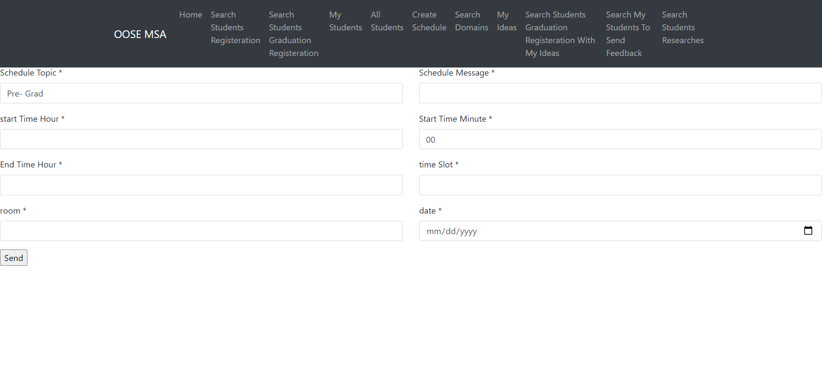

Page10:-

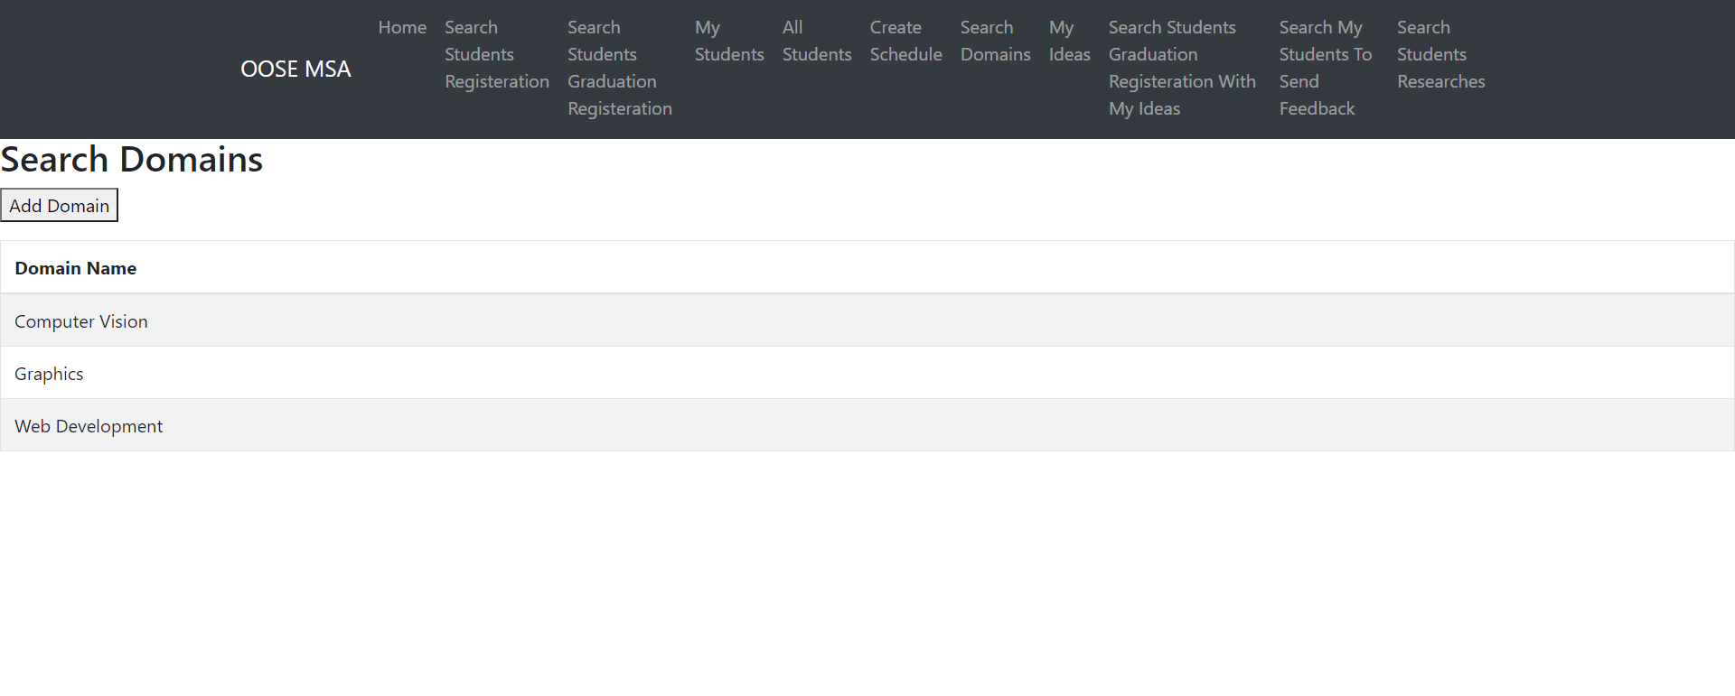

Page11:-

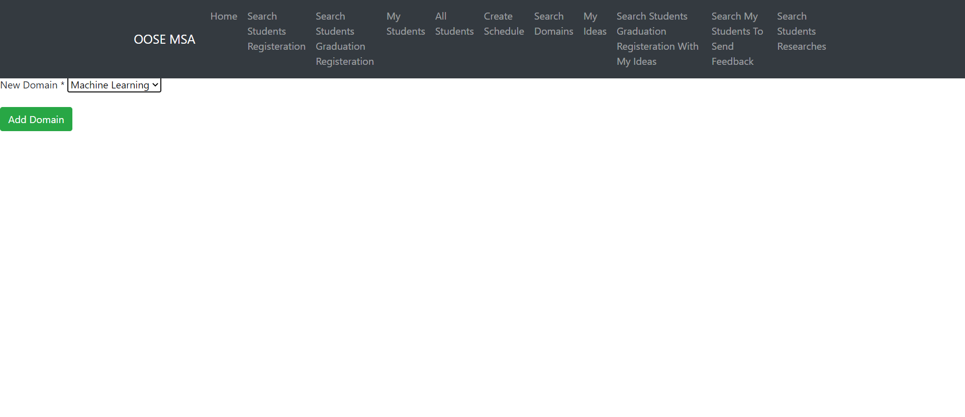

Page12:-

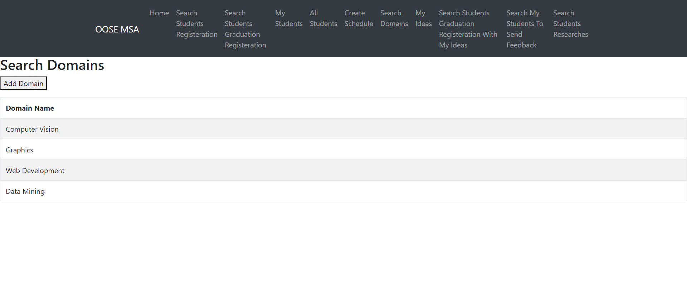

Page13:-

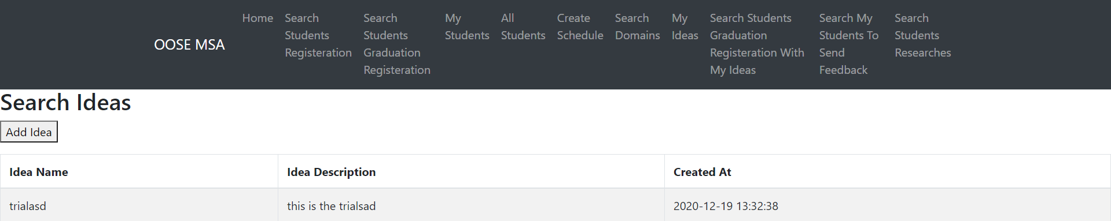

Page14:-

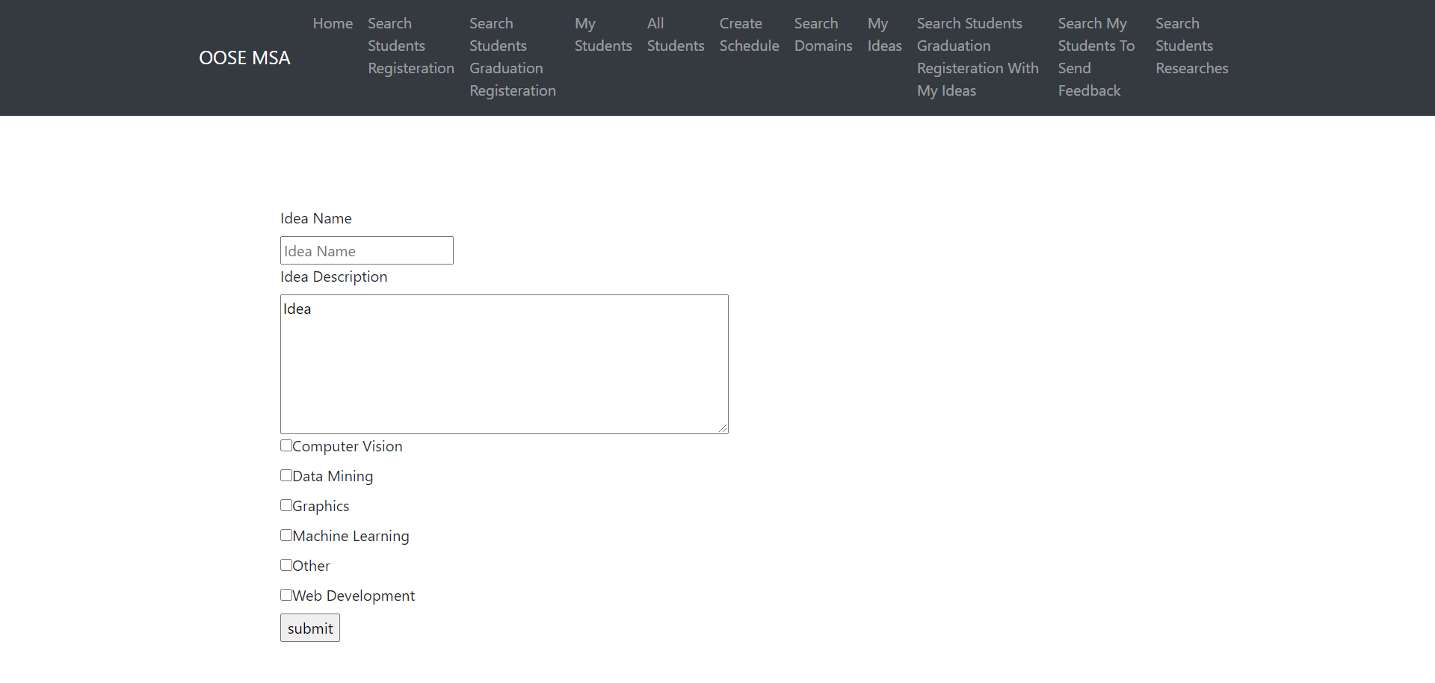

Page15:-

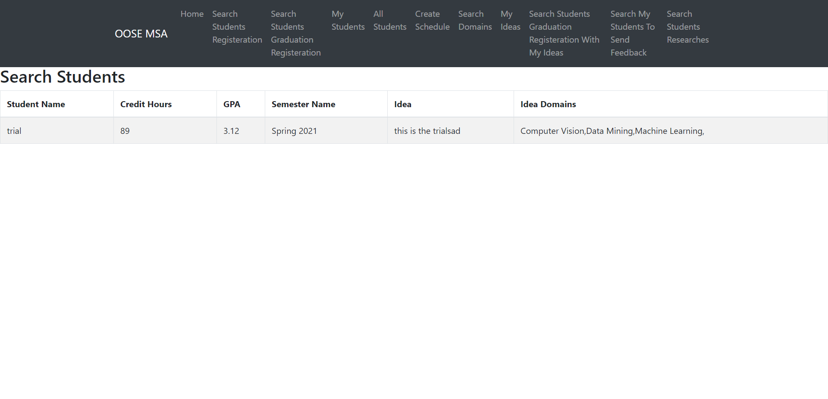

Page16:-

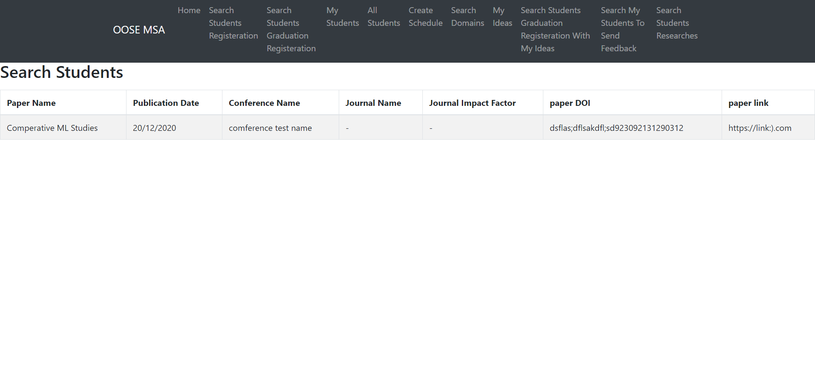

Admin Pages:-

Page2:-

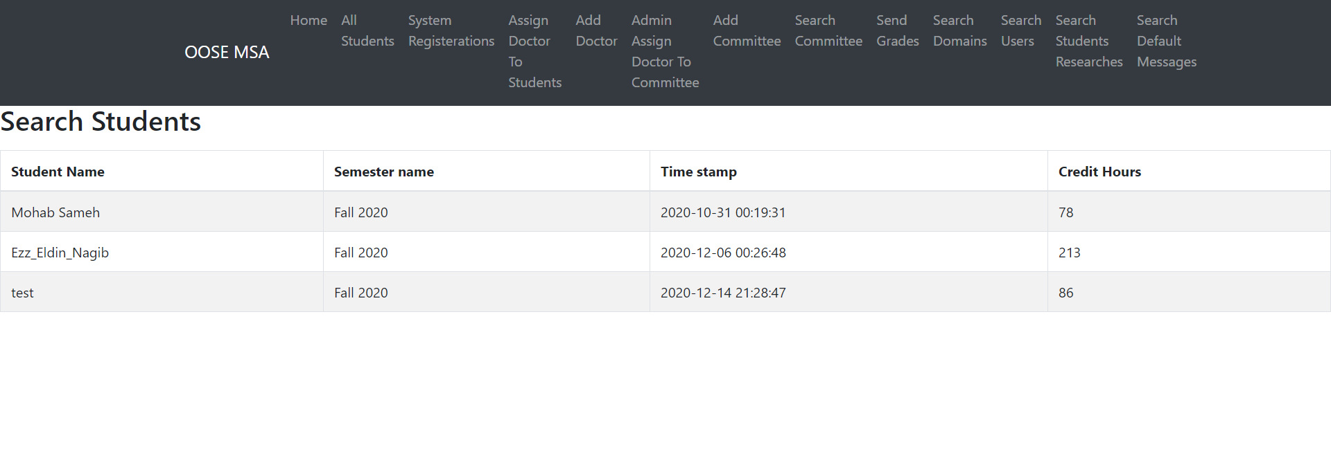

Page3:-

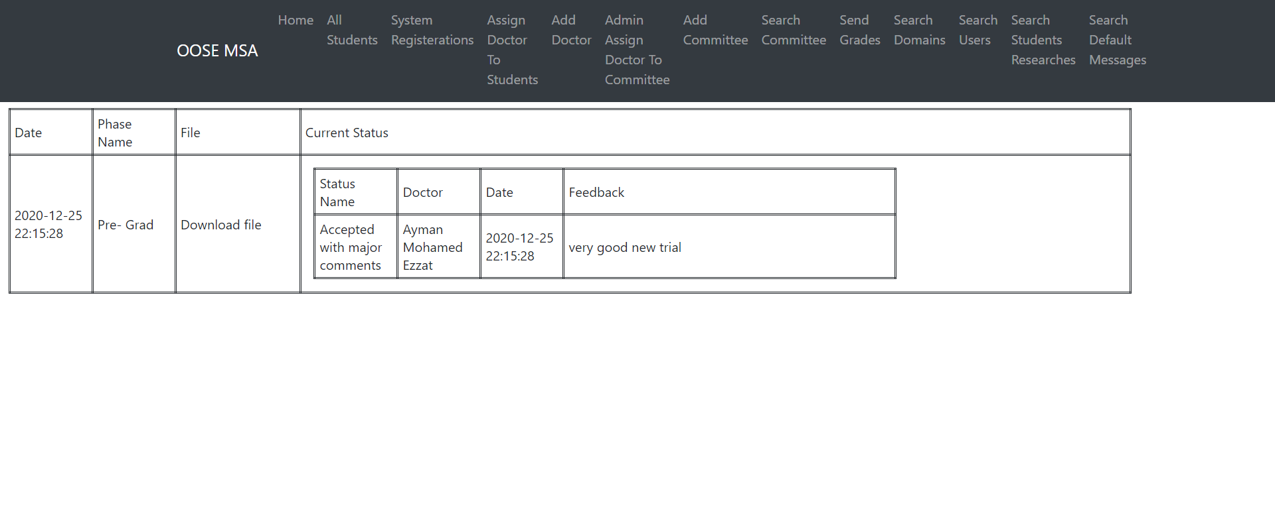

Page4:-

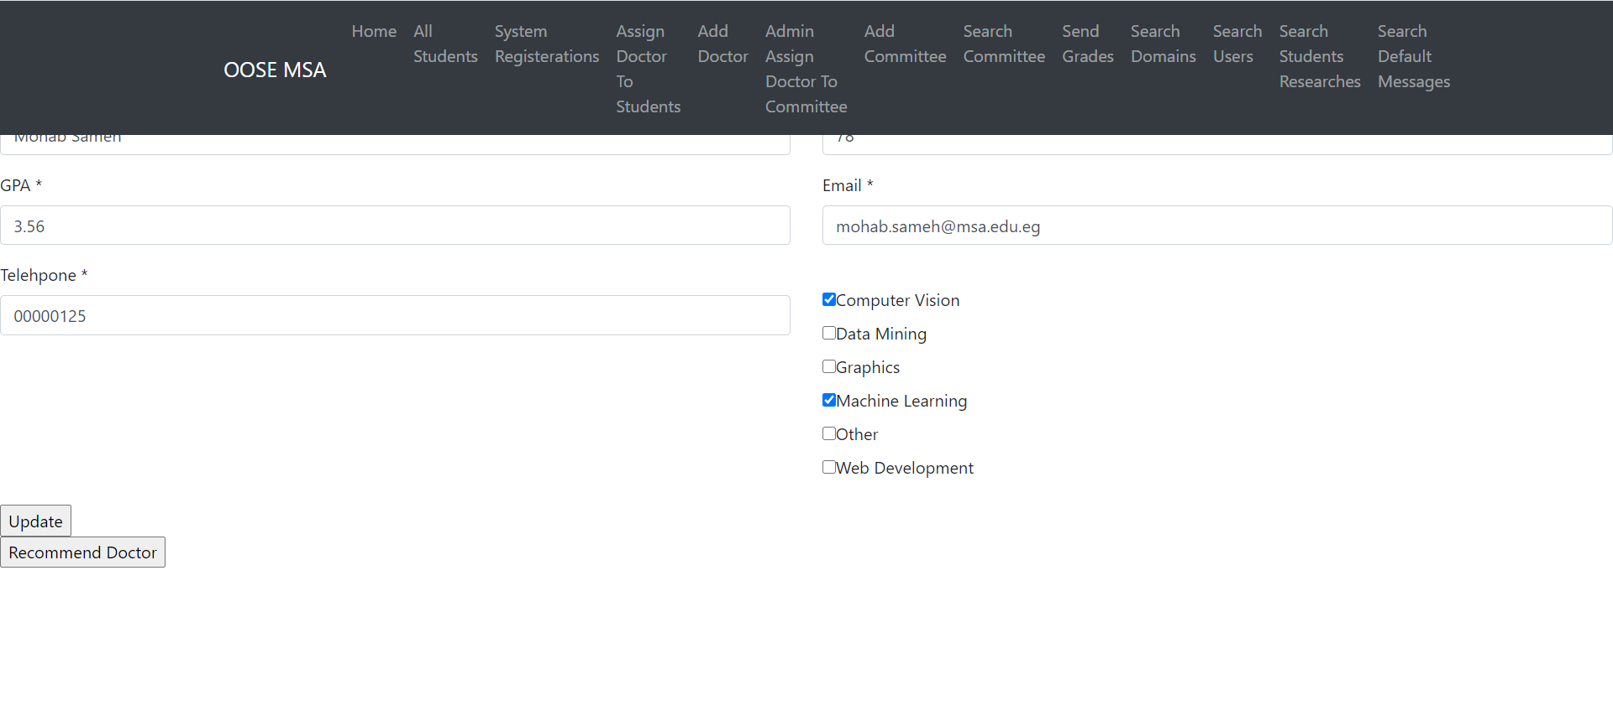

Page5:-

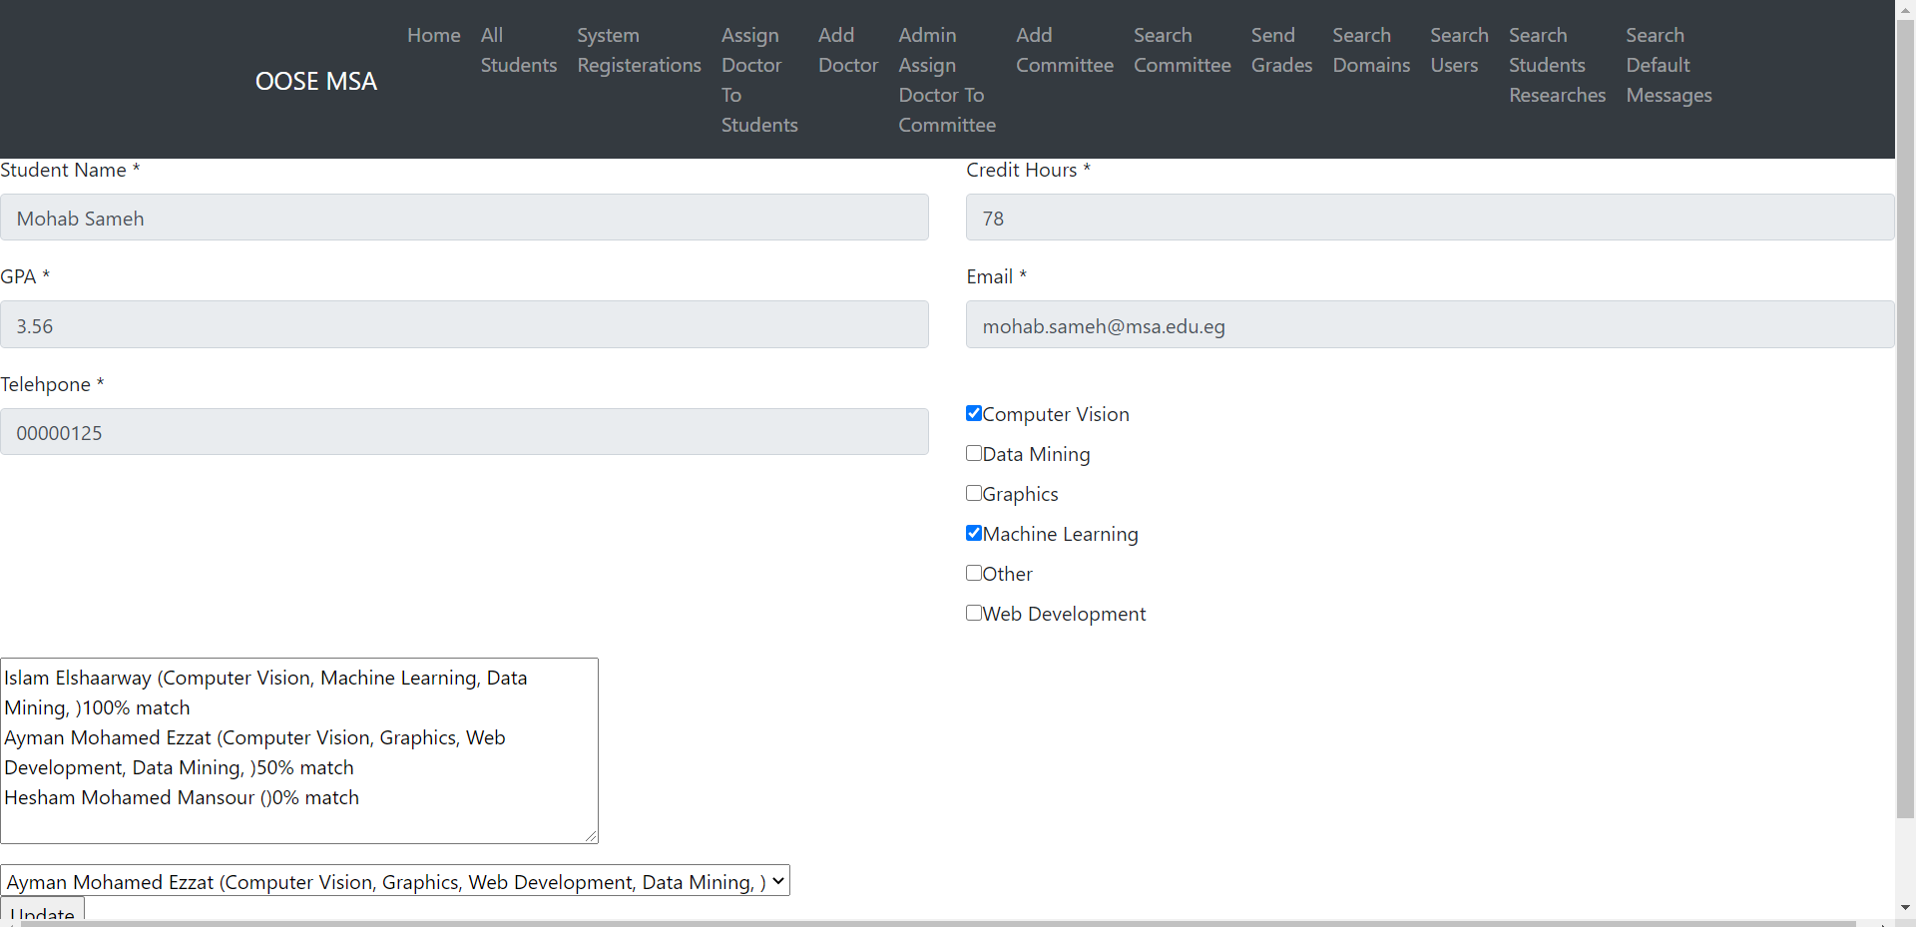

Page6:-

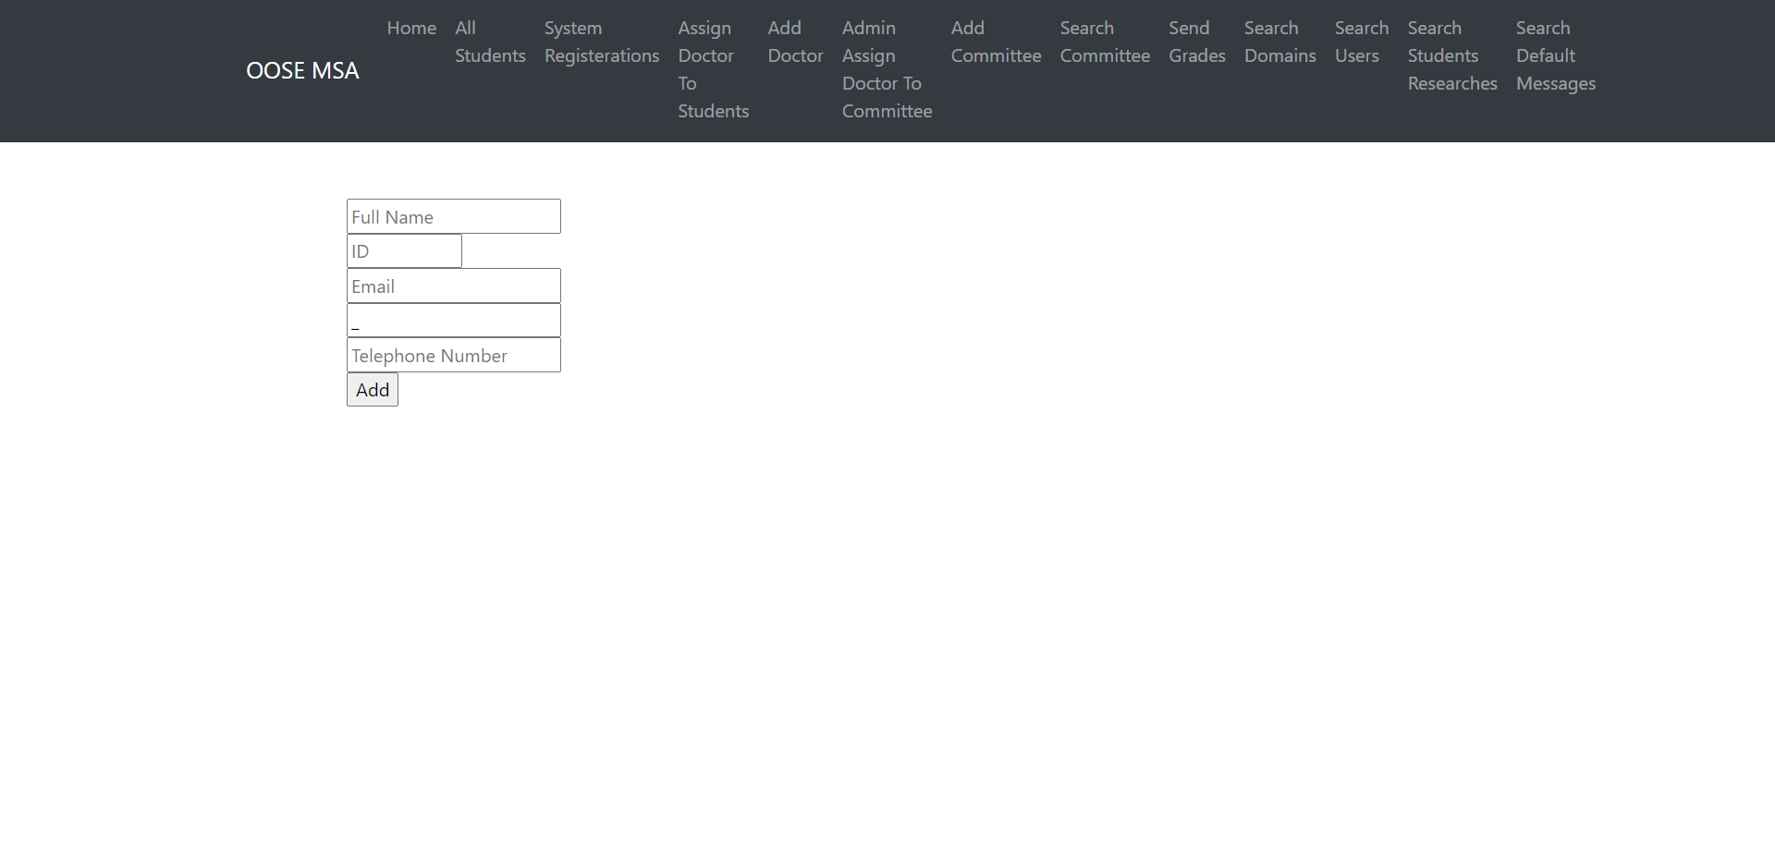

Page7:-

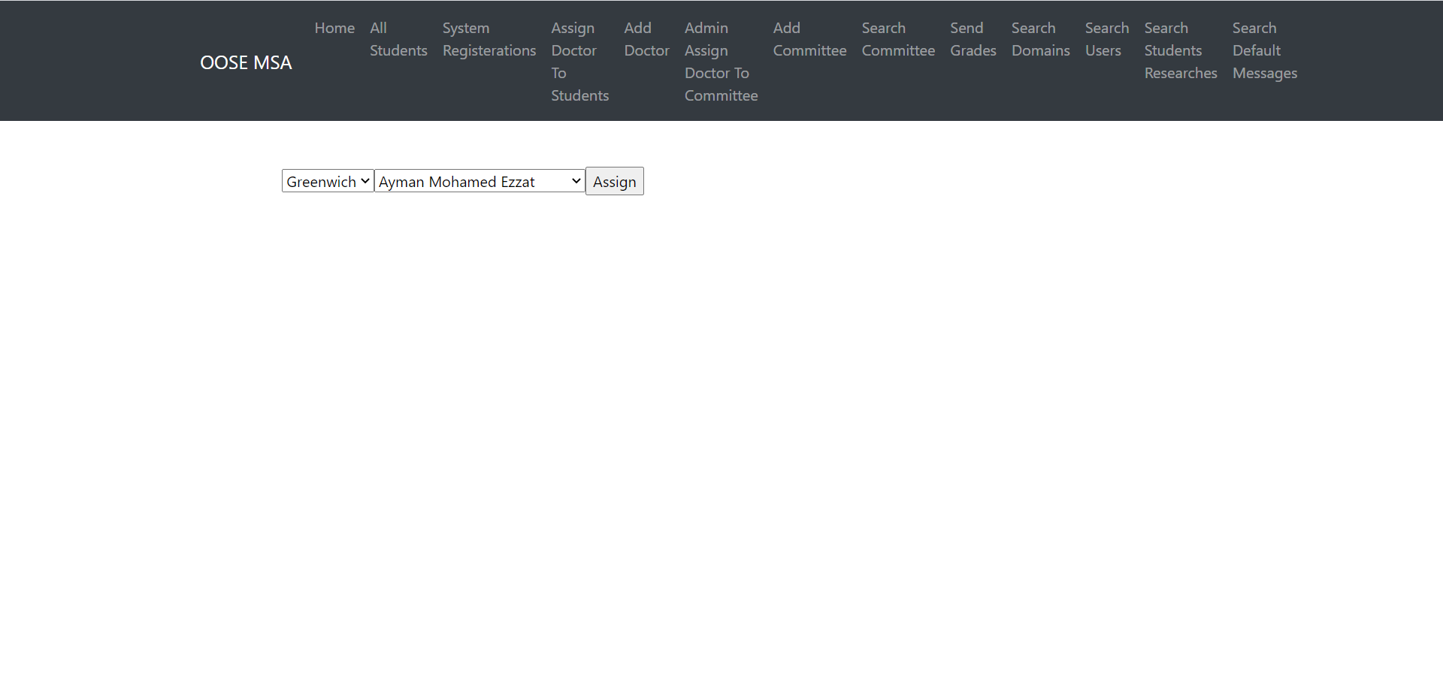

Page8:-

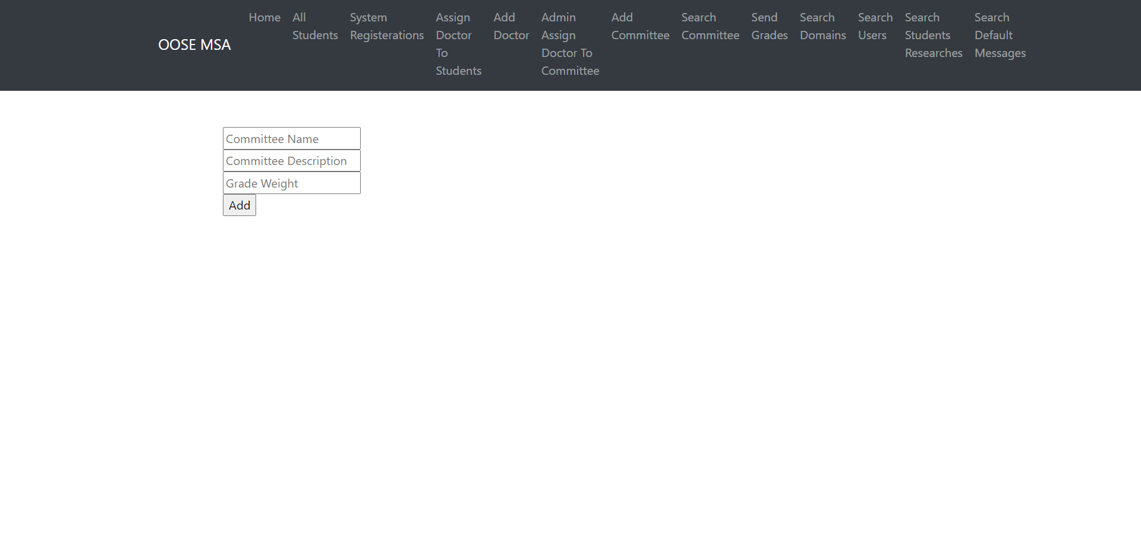

Page9:-

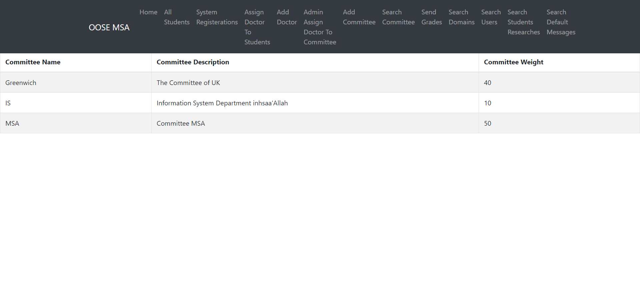

Page10:-

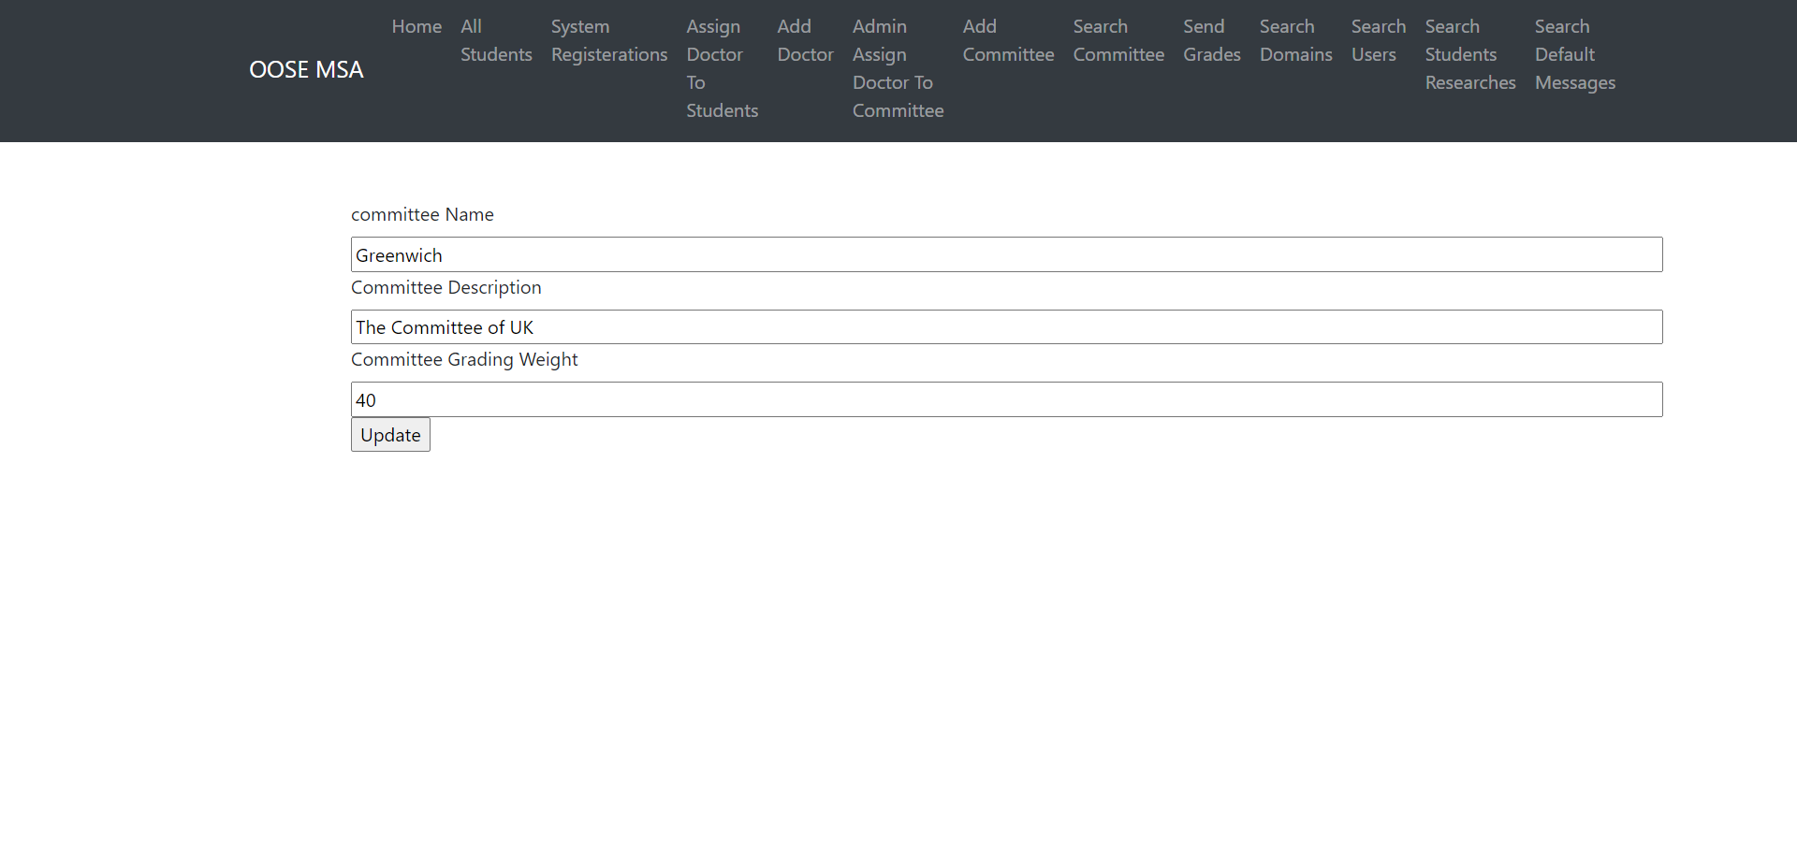

Page11:-

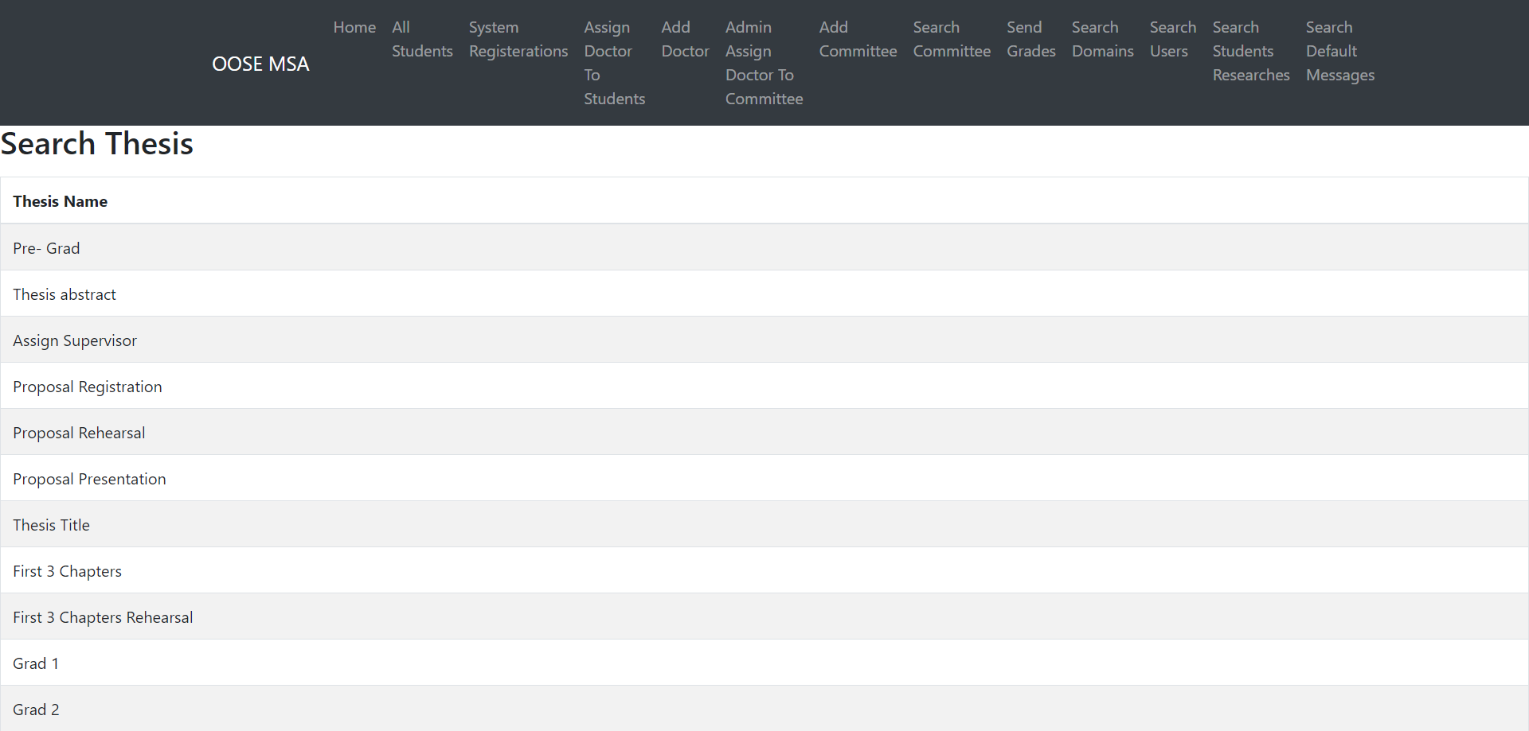

Page12:-

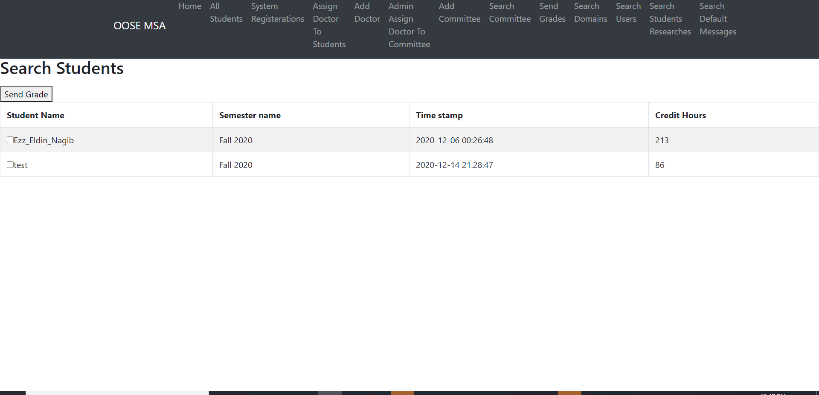

Page13:-

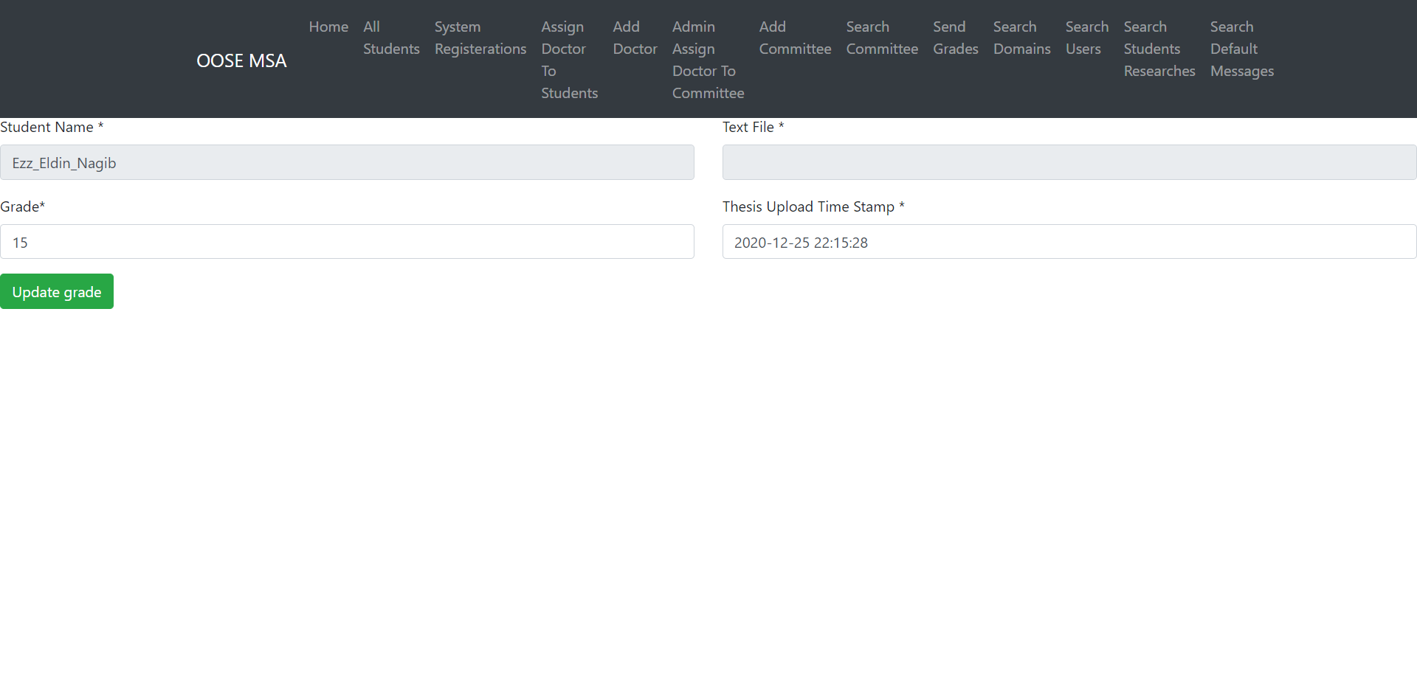

Page14:-

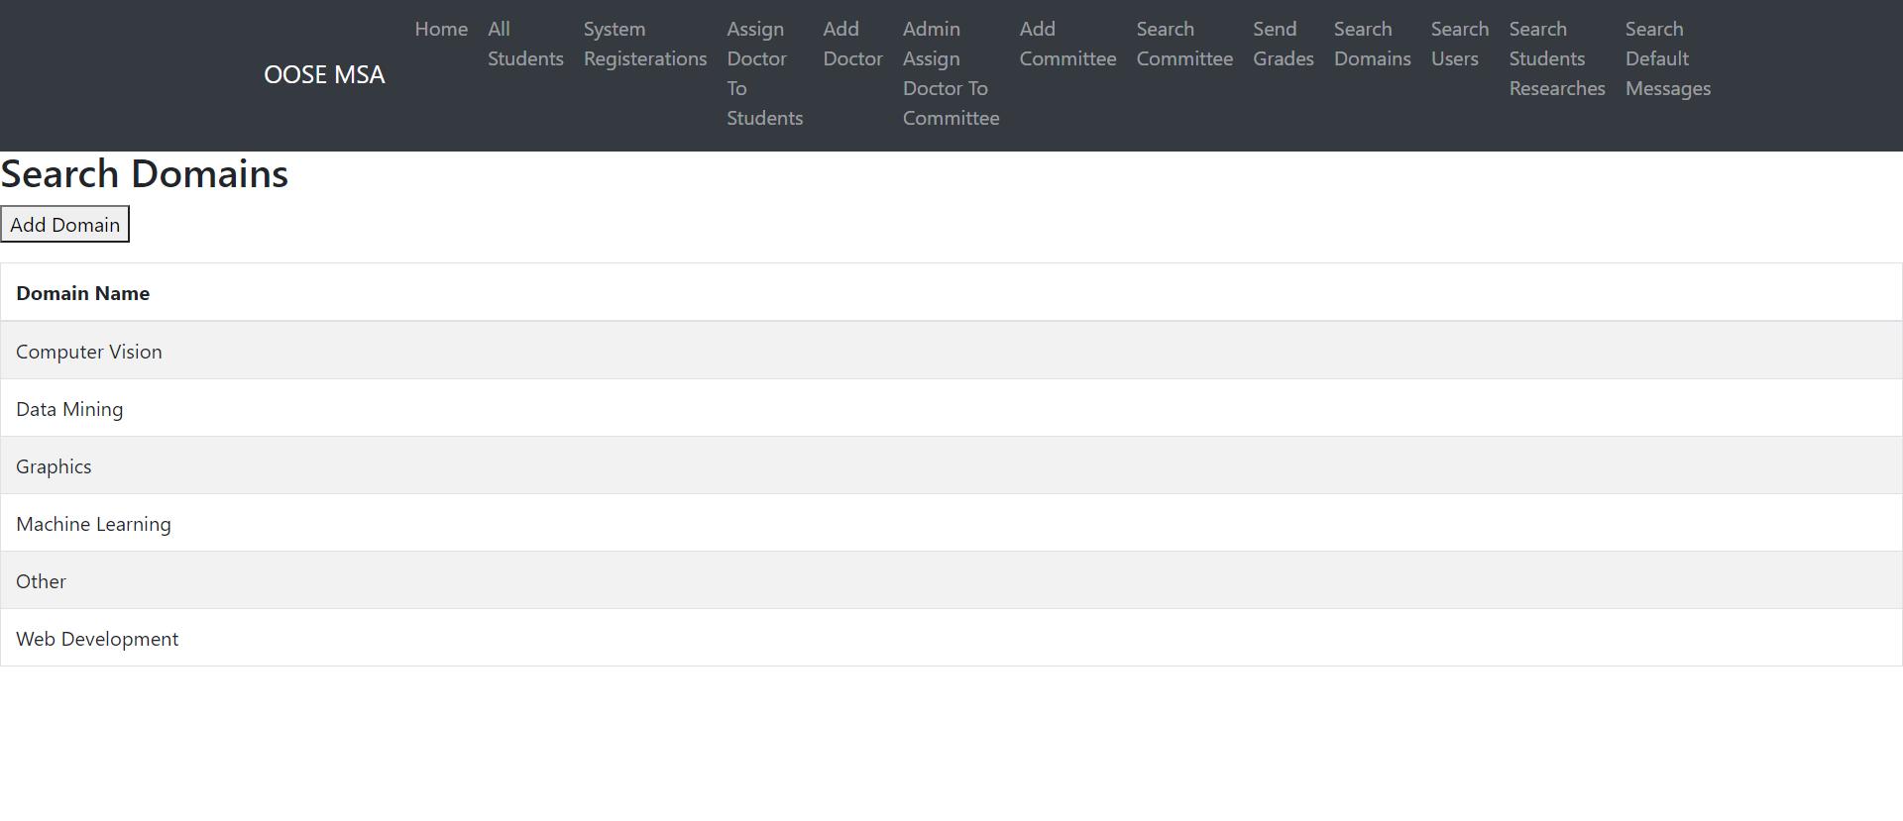

Page15:-

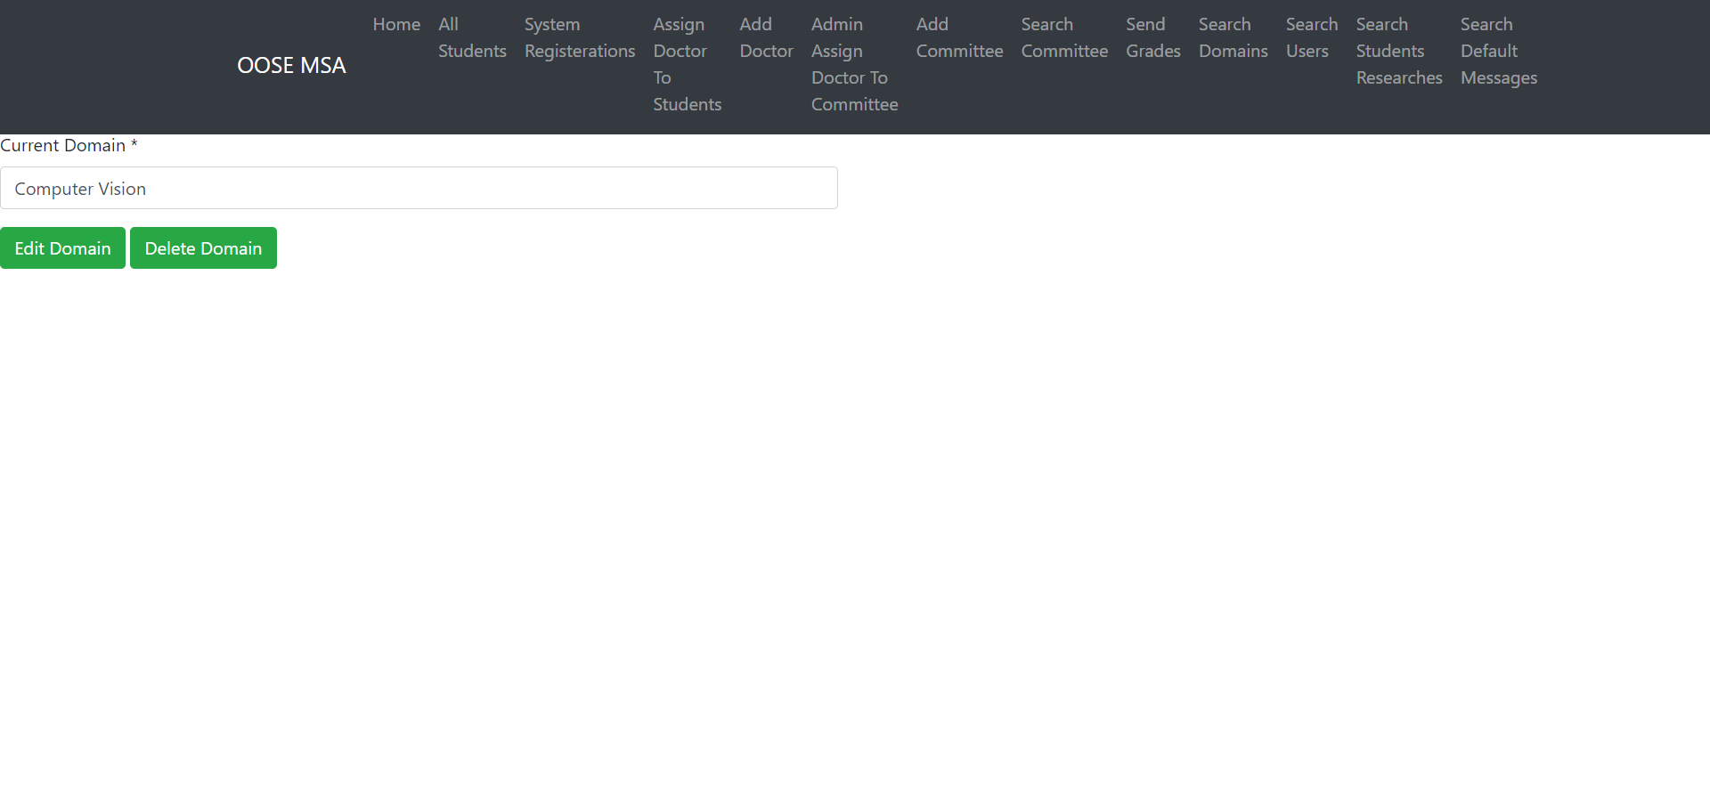

Page16:-

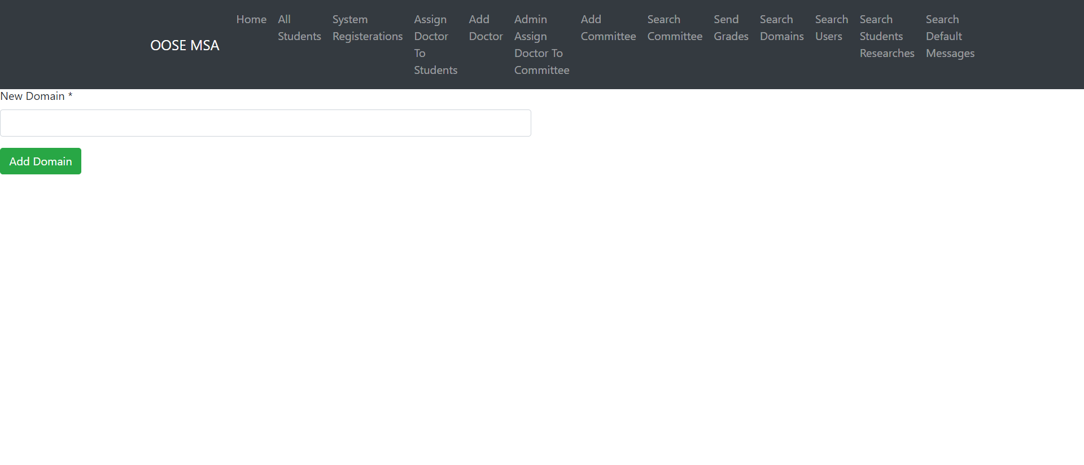

Page17:-

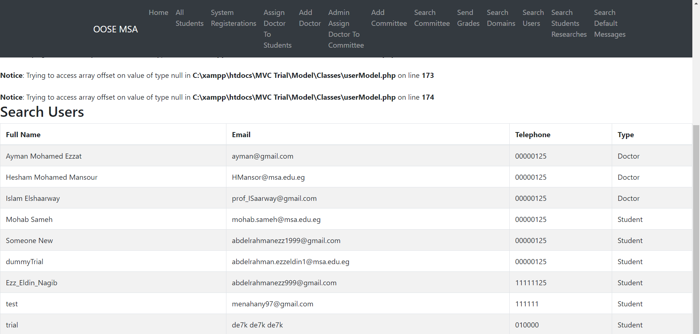

Page18:-

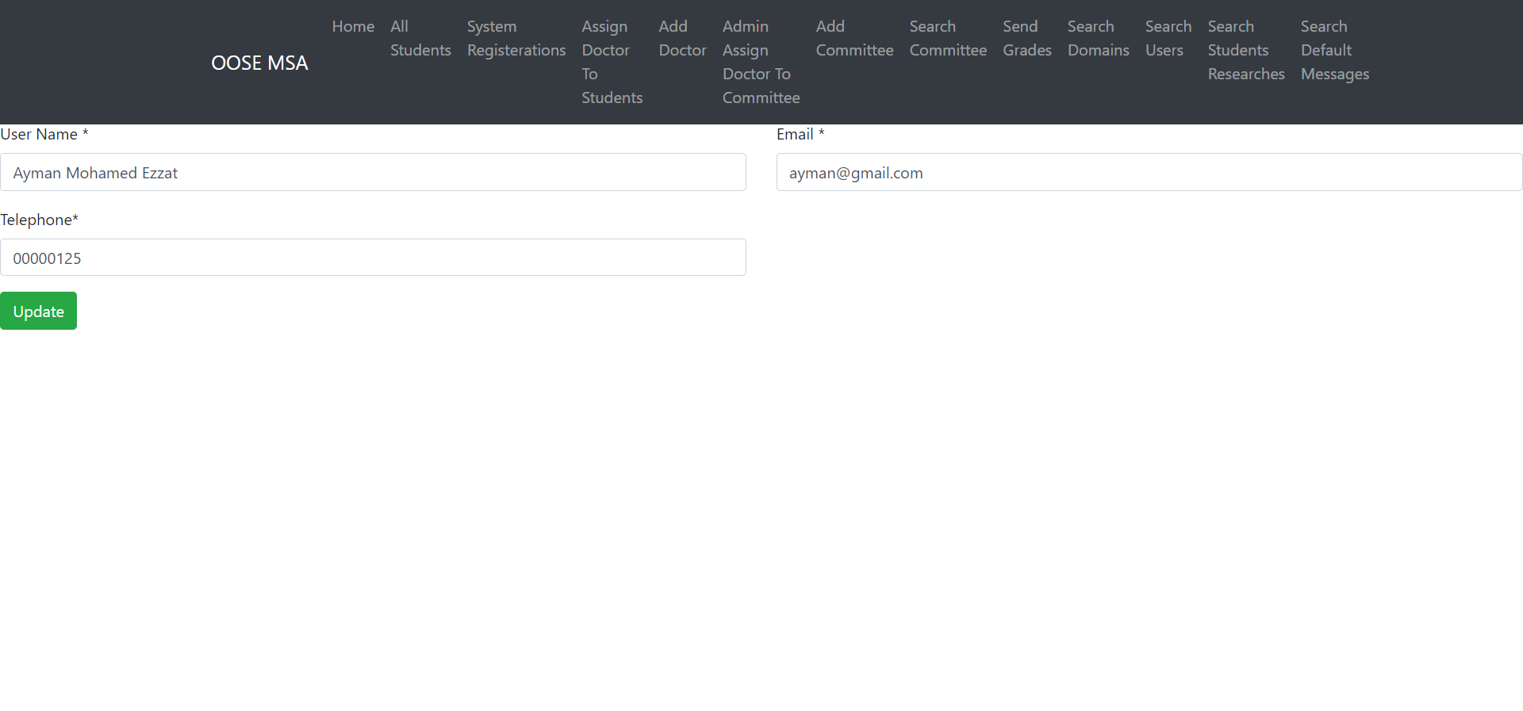

Page19:-

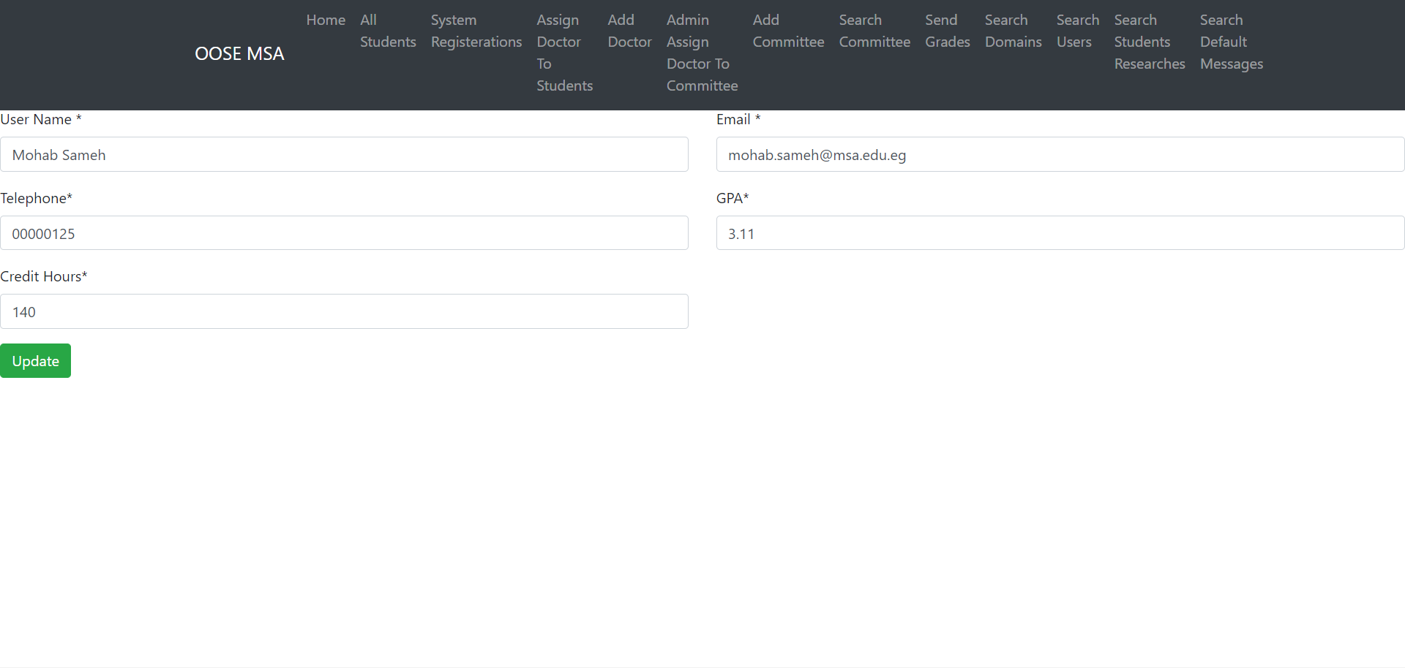

Page20:-

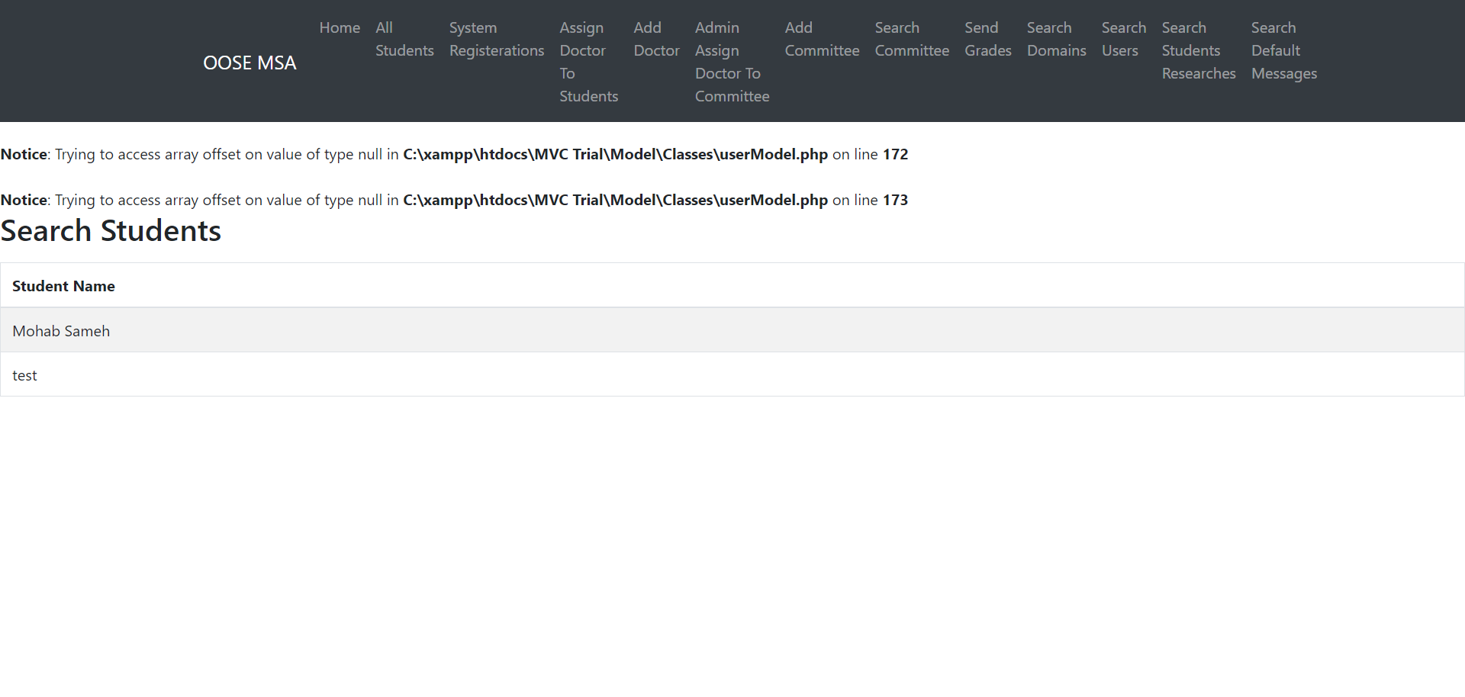

Page21:-

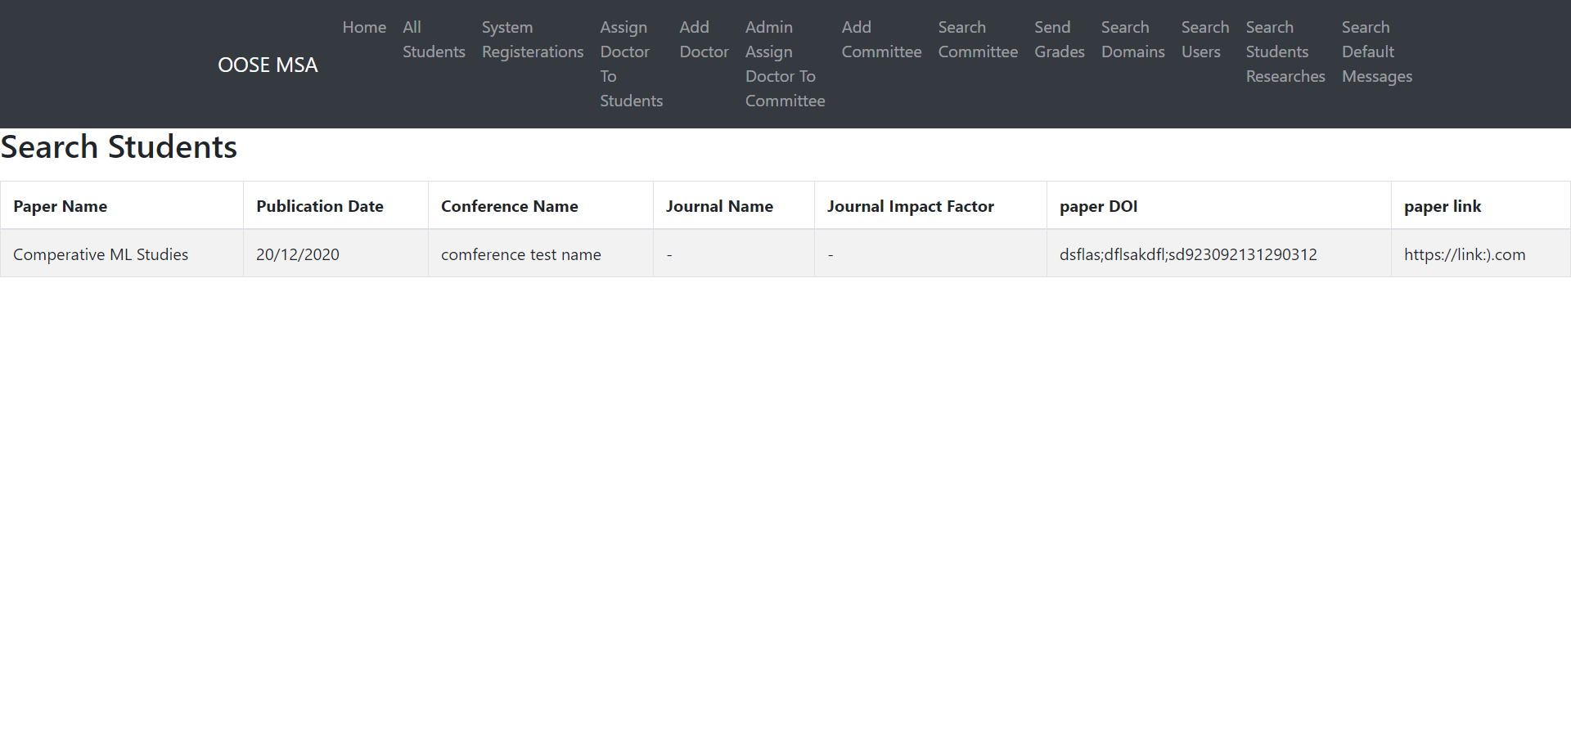

Page22:-

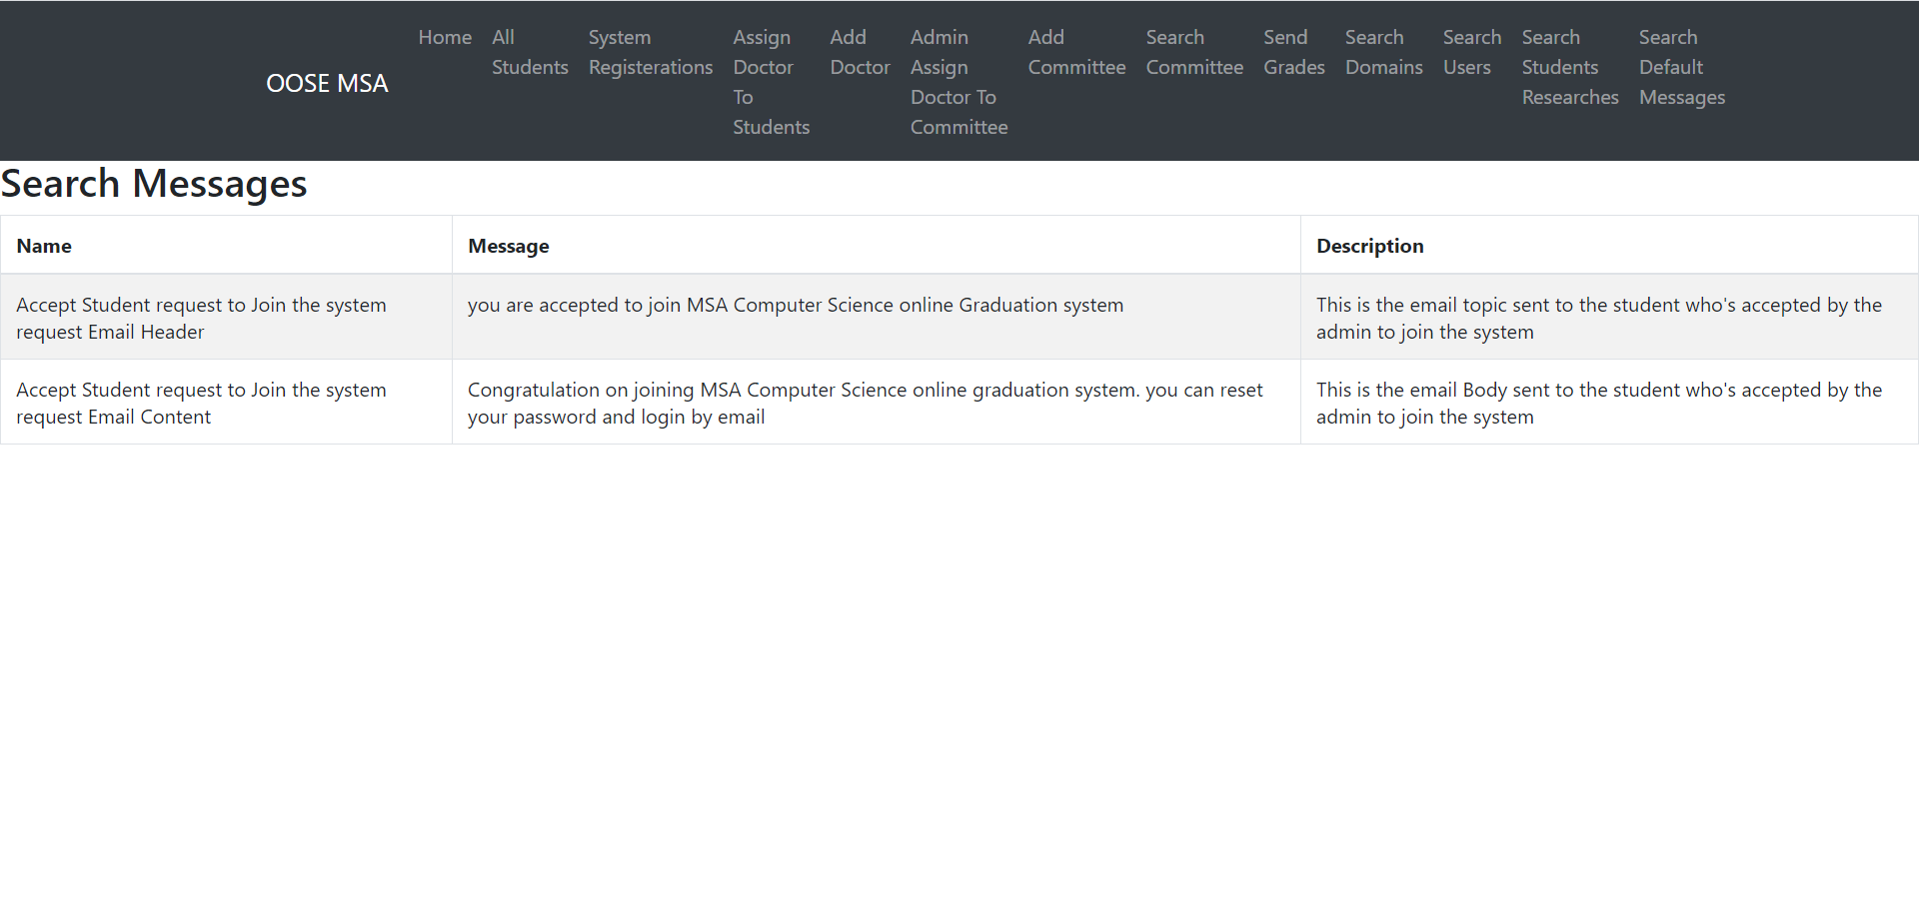

Page23:7- Requirements Matrix

